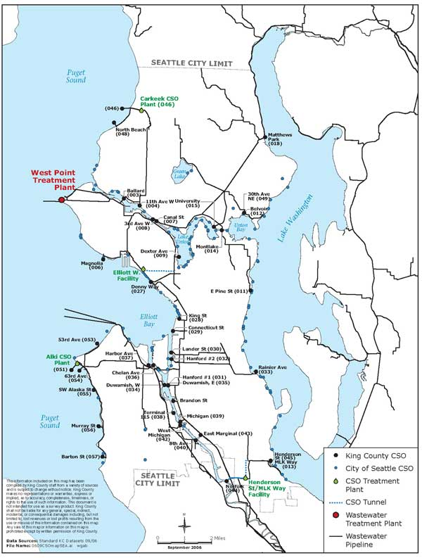

For our Grand Finale, we will track the water that goes through the “human” engineering of pipes and treatment plants, to the Sound, by visiting the West Point treatment plan.

**This assignment is due on Friday the 10th! Please email me an electronic version no later than Friday at midnight.**

**No late lab assignments will be accepted after Friday the 10th.**

1) (5 pts) Track your water usage for 1 day:

a) (1 pt) What activities required water?

b) (1 pt) Now consider not only the “obvious” uses (e.g. flushing a toilet), but also any indirect water usage required throughout the day.

c) (1 pts) Which activity(s) required the most water at the end of the day?

d) (1 pts) Estimate how many gallons of water the average person uses every day:

e) (1 pt) What did you add to this water that made it ‘dirty’?

2) (1 pts) All of the water you use throughout the day is drinking water. Where did this water come from?

3) (1.5 pts) What percent *really* needs to be drinking water quality (0.5 pts), and how much does that cost in dollars (0.5 pts) and environmental impact (0.5 pts) of diversion to drinking water?

4) (1.5 pts) Where does this water go when it leaves your house, and where does it eventually end up?

5) (2 pt) Describe 4 impacts (0.5 pts each) that the items and contaminants found in the water leaving your house would have on the sewer system and the environment—specifically the health of humans and other species—if it was discharged directly into Puget Sound or Lake Washington.

6) (1 pt) What are the differences between water that runs off a road, house or yard and into the storm drain (stormwater) vs. water that leaves a drain or toilet in your house (wastewater)?

7) (2 pt) Everything is recycled, nothing disappears. Imagine your bodies, drains and toilets are recycling bins and wastewater treatment plants are recycling centers. The water and organic solids that enter a treatment plant are separated, treated and safely recycled back into our environments as clean water or fertilizer. **What role do you play in keeping the treatment system working properly and protecting the soils and water of Washington State?** List four choices (0.5 pts each) you can make to help the system run efficiently and keep the recycled fertilizer and water safe and clean.

8) (2 pts) Predict what happens if too much water enters into:

a) (1 pt) a pipeline

b) (1 pt) a treatment plant:

9) (2 pts) As communities grow and more wastewater is generated, more water enters the treatment system. List four different ways (0.5 pts each) to manage the problem of increased wastewater flows:

10) (2 pts) Think about all of the pipes and pump stations that help move dirty water away from your home or school.

a) (0.5 pts) How old are they?

b) (0.5 pts) How big are they?

c) (0.5 pts) What are they made of?

d) (0.5 pts) What happens when they get old?

10) (1 pt) Who pays for wastewater treatment? How?

