During this lab exercise we will explore a computerized model of the Puget Sound Basin. We will use the Collaborative Ocean Visualization Environment (COVE), which is being developed at UW, to visualize various oceanographic datasets. We will explore oceanographic properties in Puget Sound such as temperature, salinity and circulation. The interface allows you to choose a wide range of views of simulated data that were generated previously by a numeric model.

Our goal for this lab is to understand how these physical parameters interact to create oxygenated versus anoxic conditions in the water column. Specifically, we are interested in understanding the physical oceanographic mechanisms responsible for the low levels of dissolved oxygen in Hood Canal. By comparing different sites throughout the Sound, you will be able to visually comprehend how water stratification and flushing rates (the two major physical causes of the O2 problem) affect these properties.

The geology and bathymetry of Hood Canal play a large role in the water quality and dynamics of how the water moves. The entrance to the canal is a relatively shallow sill, but just south of the entrance the canal becomes very deep. This sill at the entrance creates a condition in the canal that doesn’t allow deep water to flow or exchange very easily with the changing tides and seasons. Flushing rate in the canal is on the order of 1-2 years, while outside the Canal in the Main Basin the flushing rate is 2-3 months.

**Introduction to COVE data visualization software**

Click on the “COVE” icon on the desktop to load the program.

1. Navigation in COVE is similar to what you’re used to with Google Earth Pro. Click and hold the left mouse button to move your location on the map (pan).
2. To zoom in and out use the scroll wheel on your mouse or click and hold the two sided arrow in the center of the compass rose (bottom right). You can change the North/South orientation as well as the angle of your view by clicking and holding the scroll wheel oor the outer ring of the compass rose. To return to a normal overhead view push the zero key
3. To control the lighting intensity and direction of shading, adjust the circular slider tool to the left of the compass rose.
4. The dashboard at the top of your screen has many useful tools, such as a distance measuring tool, the ability to view the earth as a spherical or flat image, and the ability to toggle UTM or Lat/Long coordinates. The “Data Layers” tool allows you turn on/off different layers as we did in Google Earth Pro. The “Settings” tool allows to customize how data is visualized.
5. On the second row of dashboard tools you will find a list of different “Views.” These are pre-made views of certain data and locations. You can create your own view by clicking the “Save new view” button if you’d like to be able to easily go back to a certain region of interest. Before starting the lab exercise, familiarize yourself with navigating thru COVE. \***IF YOU ENCOUNTER ERRORS CLOSE AND RESTART THE PROGRAM\***

**Part I: Exploring Puget Sound Bathymetry (1.25 Points)**

To begin, select the view labeled “Bathymetry” from the COVE dashboard. This will display a data layer containing moderately high resolution bathymetry for the sea floor. As you zoom in to Puget Sound, the view will become more detailed. There is a legend showing you the scale of depths on the lower left corner of your screen. Also, when you scroll your mouse over an area, you are given the lat/long and also the depth or altitude of that location on the upper right corner of your screen.

1. (0.25 pts) Where are the shallowest regions of Puget Sound (i.e. what basin)?
2. (0.25 pts) Where are the deepest regions of Puget Sound (i.e. what basin)?
3. (0.75 pts) Identify the latitude/longitude and depth of the sills at
4. Hood Canal:
5. Main Basin:
6. South Sound:

**Part II: Surface Salinity and Temperature of Puget Sound (2.5 points)**

1. Select the “Salinity Surface” view from the COVE dashboard. This data layer displays surface salinity in the Puget Sound basin and coastal ocean. The data has been generated by a numeric ROMS model (Regional Ocean Model System) and represents a snapshot of surface properties for January 6, 2005.

## (0.25 pts.) In what areas of Puget Sound is the surface salinity the highest?

## (0.25 pts.) In what areas of Puget Sound is the surface salinity the lowest?

## (0.5 pts.) What 2 factors drive these differences in salinity?

## Now click on the “Data Explorer” tool on the COVE dashboard. In the pop-up box click on the “Color” subheading. This tool allows you to change the colors used to display data as well as change the maximum and minimum values used to scale the data.

## (0.25 pts) In the “Data Explorer” select the “Bins” box under the “Colors” heading. How does this change your view of the data?

## (0.5 pts) Change the maximum and minimum values of the scale to 0 and 25 (make sure there is a check mark on the boxes next to Min and Max values). With this scale what major features can you see more prominently, and why?

1. Repeat this exercise using temperature in place of salinity. To change to the surface temperature data layer, open the “Data Explorer” tool and click on the drop down menu labeled “Variable Displayed” at the top of the pop-up box. Select “temp” from the drop down menu. Notice that the scale will still be set to what you had for salinity, and the data may not show up properly. To have a scale automatically generated, uncheck the boxes next to “Minimum Value” and “Maximum Value” under the “Color” subheading.

## (0.5 pts.) In what areas of Puget Sound is the surface temperature the highest, and what is the approximate temp (scale is in degrees Celsius)?

## (0.25 pts) What is the range of temperatures across the entire Hood Canal basin?

**Part III: Salinity and Temperature Cross Sections (3 pts)**

1. Select the “Salinity cross-section” view from the COVE dashboard. This view allows you to look at the vertical profile of salinity or temperature across a section of your choice. The default cross section goes thru the Straits of Juan de Fuca into the Main Basin. You can make the 2d side view window larger or smaller by clicking and dragging the bottom right corner of the window.
2. (1 pt.) Using the default cross section, at what depths of Puget Sound is the salinity generally the greatest? What causes this salinity difference?
3. (1 pt) Open the “Data Explorer” tool, and change the Variable Displayed to temperature (You may need to uncheck the min/max value boxes under the “Color” subheading). Using the default cross section, at what depths of Puget Sound is the temperature generally the greatest? What causes this temperature difference?
4. To customize the path of the cross section, open the “Data Explorer” tool and click on the “Display” subheading. Click on the “Edit Path” button, which will bring up a new window. You should see spheres along the line of your cross section. Left click and drag these spheres one by one to change the path of your cross section.
5. (0.5 pts) Create a cross section of the whole Hood Canal basin. Show your instructor your cross section to get credit for this question.
6. (0.5 pts) Where are the highest temperatures in the Hood Canal basin (i.e. general location and depth)?

**Part IV: Vertical Salinity Profiles at PRISM Cruise Stations (2.5 pts)**

1. Select the “Salinity Profiles” view from the COVE dashboard. This view displays salinity profiles collected during the December 2004 PRISM cruise. Note that these stations include the same ones that you visited during the Thompson cruise. The data that you collected on your cruise can be visualized in the same manner. By clicking on the colored profile you can get exact salinity values for each depth of the profile.
2. (0.25 pts) Find the station at the entrance of Hood Canal (lat/long: 47.896500, -122.603667). What is the range of salinities here (i.e. exact values from surface and bottom)?
3. (0.25 pts.) Find the station in the middle of the North Main Basin (47.812667, -122.453833). What is the range of salinities here (i.e. exact values from surface and bottom)?
4. (0.25 pts) Find the station near the north end of the Whidbey basin (48.238667, -122.556833). What is the range of salinities here (i.e. exact values from surface and bottom)?
5. (0.75 pt) Based on the above results, rank the 3 stations from most stratified to least stratified.
6. (1 pt) What factors make these stations more or less stratified relative to one another?

**Part V: Puget Sound Circulation and Current Velocities (4.25 pts)**

1. Select the “Surface currents” view from the COVE dashboard. This view displays modeled current velocities as vectors over a 24-hour tidal cycle. The direction of the vector indicates the direction of flow. Warmer colors (red) indicate higher current velocities; once velocities reach zero, the vector becomes transparent and disappears. Using the timeline on the bottom of the screen, you can either manually move thru time by dragging the timeline or simply push the play button. The spatial extent of this dataset has been reduced to limit the memory demand on the computers.
2. (0.5 pts) In this dataset, where are current velocities generally the highest, why?
3. (0.25 pts) Where are current velocities generally greater throughout the tidal cycle, the entrance of Hood Canal or the entrance of the Main Basin?
4. (1 pt.) What 2 main factors drive circulation (i.e. currents) in Puget Sound?
5. To have an easier time determining the direction of currents you can display the vectors as arrows (warning: this will slow down the computer, so be patient). Make sure your timeline is stopped, then open the “Data Explorer” tool. Under the “Display” subheading, click on the “Show Arrows” box. To make the arrows nicer to view, change the length setting to 0.12 and width setting to 0.24
6. (1 pt.) Zoom in on the Straits of Juan de Fuca, near where this dataset ends (where you can still see some arrows) and manually move the timeline to observe how the direction of current movement changes throughout the day. What time do the first high and low tides of the day occur? Remember there are 2 highs and 2 lows, so only look at the first half of the day to fill out the following table:

|  |  |  |  |  |
| --- | --- | --- | --- | --- |
|  | Ebb | 1st Low tide  (slack) | Flood | 1st High Tide  (slack) |
| Time |  |  |  |  |

1. Select the “Currents Different Levels” view from the COVE dashboard. This view displays current velocities at three depths. The red vectors are surface velocities, yellow is mid-depth, and blue is near the bottom. As velocities reach zero the vectors become more transparent. To view the different depths you will need to angle your view so that you are looking into the basin (see figure below).

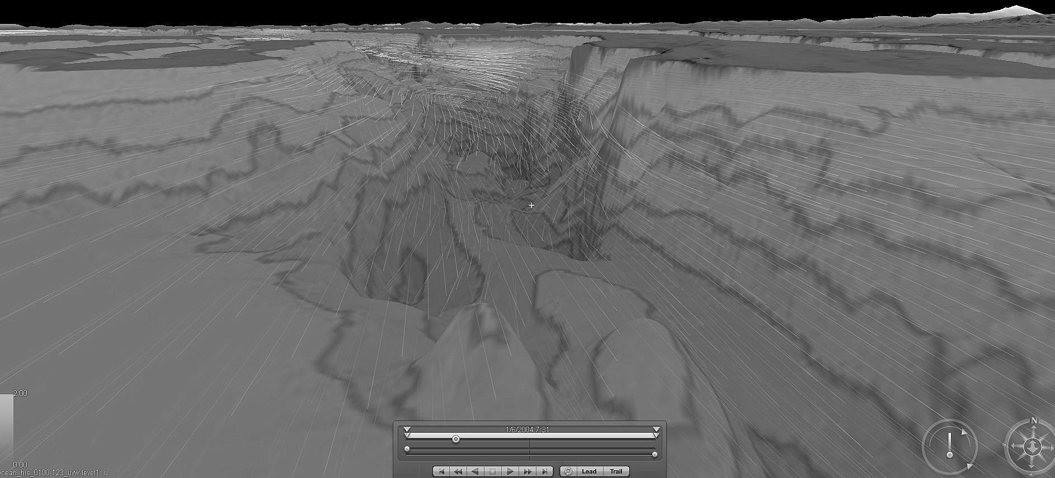

1. (0.25 pts.) Zoom in so that you can see the current velocities at all 3 depths simultaneously near the entrance to the main basin (48.056976, -122.624195). During an incoming (flood) tide, does the water move landward at all depths?
2. (0.5 pts) Explain any observations you have about the magnitude timing of the currents at each depth during the flood tide (i.e. does one depth start incoming sooner/later or weaker/stronger than the others?)
3. (0.25 pts.) During an outgoing (ebb) tide, does the water move seaward at all depths?
4. (0.5 pts) Explain any observations you have about the magnitude timing of the currents at each depth during the ebb tide.

**Part VI: Particle Advection (3 pts)**

1. Select the “Advection” view from the COVE dashboard. Similar to dropping dye or beads into the physical model, this view shows you the path/destination of neutrally buoyant particles dropped at a certain location based on the currents you observed in Part V. The default color scale relates to the speed of the particle (i.e. the speed of the currents that the particle is in). Each particle starting location has many paths coming off of it, which show particles dropped at different starting times.
2. (1 pts.) Open the “Data Explorer” tool. From the “Display” subheading, click on the drop down box labeled “Value.” Select “Start time” instead of speed. This will color the paths based on when the particle was released (blue released first, yellow released last. What do you notice about the direction of movement of the particles released first vs. last? Why is this?
3. (1 pts.) From the “Data Explorer” tool, click on the “Edit Particles” box, this allows you to move the origin of the particles by clicking and dragging the blue circle connected to the particle paths. Drag a particle origin out to the straights of Juan de Fuca. What is the net direction of movement of all particles released over the 24 hour tidal cycle? Why is this? (hint: these particles are released on the surface).
4. (0.5 pts) From the “Data Explorer” tool, uncheck the “Release Particles Over Time” box. This lets you look only at the first particle dropped at the beginning of the tidal cycle. If you dropped your hat off of the Thomas G. Thompson at exactly lat/long 47.664249, -122.455843, where would your hat wash ashore (lat/long and name of location)?
5. (0.5 pts) If you fell off of the Thomas G. Thompson at exactly 48.319864,-123.211784, how far would you float by the end of the day (distance from start to end, not total distance travelled)?

**Part IV: Questions to Answer after Lab (3.5 pts)**

# Answer the questions below based on your results using VPS in the lab and your knowledge of Hood Canal from lecture and the Hood Canal web page [www.hoodcanal.washington.edu](http://www.hoodcanal.washington.edu)

## (0.5 pts.) What is the typical pattern of net surface & deep currents that you expect in an estuary?

## (0.5 pts.) What processes explain this typical pattern of net estuarine circulation?

## (0.5 pts.) How does the magnitude of net flow at the surface and at depth determine the flushing rate of an estuary?

## (0.5 pts.) How does the flushing rate inside Hood Canal compare to the N. Main Basin? Why?

## (0.5 pts) What chemical and biological effects might you expect to observe at the surface in southern Hood Canal after a strong southerly wind in September, for example? Why?

## (1 pt.) Go to the Hood Canal web page and click on the photo of the “ORCA buoy” to go to a page with links to real-time data and weather. Choose the link to “Hoodsport Data.” Using the blank figures below, draw in the profiles for the latest data displayed on the page, and enter the date and time that the data were transmitted. Is there a low-oxygen layer evident at this location, date, and time? **Y/N** If so, at about what depth? ______

Data Date and Time: ___________________________________

