Laboratory Exercise 6:

Modeling dissolved organic carbon export with subsurface flow

Lab Objectives:
- Understand processes affecting DOC cycle in soil.
- Use VSB to generate necessary input files for the water chemistry model and run the chemistry model in SIMILE (a simplified version to simulate DOC export from a soil layer)

Background
This lab requires basic knowledge on how to manipulate a model in SIMILE and on soil DOC processes. Today, we will firstly use VSB framework to generate water chemistry model inputs (hydrologic data and watershed attributes). Then, we learn how to look at input parameters inside SIMILE, make custom changes to the inputs, run the model, and select output variables and formats.
The dynamics of soil DOC are described in "CONTROLS ON THE DYNAMICS OF DISSOLVED ORGANIC MATTER IN SOILS: A REVIEW" (Kalbitz et al., SOIL SCIENCE 165(4), April 2000, pp 277-304). Our simplified representation of terrestrial system and the DOC processes are shown below. The watershed is represented as a series of soil nutrient pools (soil layers) and we will only look at the the dynamics of DOC inputs from atmospheric deposition and detrital litter above ground and the export of DOC from the top soil (layer 0).
Reservoir 3
Reservoir 0
Reservoir 1
Reservoir 2
The DOC processes involve absorption to the soil particles and the transformation of DOC to CO2 due to microbe respiration
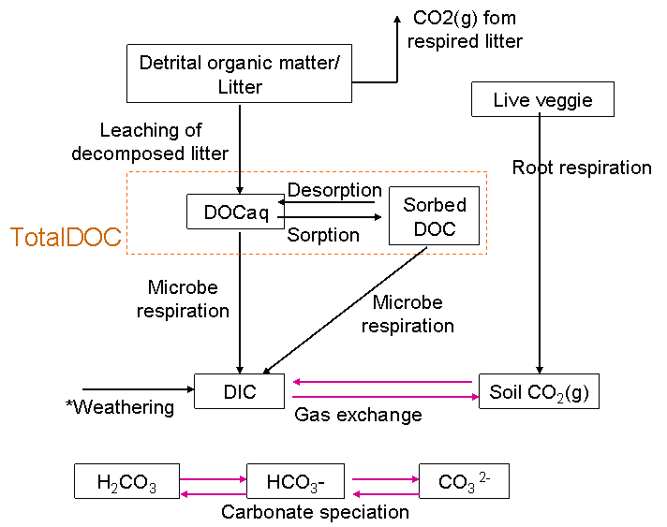

Key equations

1. Detrital organic matter decomposition

Flux of detrital organic carbon loss due to decomposition, mg C/m²-3hr
Rate constant for decomposition of detrital organic carbon, 1/3hr
Mass pool of detrital organic carbon in the soil layer, mg C/m²
Temperature factor, dimensionless
Flux of DOC leaching from decomposed litter, mg C/m²-3hr
Fraction of decomposed detrital organic carbon available for leaching,
dimensionless

2. Microbe respiration of DOC in following 1st order kinetics.

Flux of respiration of DOC, mg C/m²-3hr
Rate constant for decomposition of DOC, 1/3hr
Mass pool of DOC in the soil layer, mg C/m²
Temperature factor, dimensionless
Moisture factor, dimensionless

3. DOC sorption equilibrium based on initial mass isotherm based on Narvin (1986).

Amount of DOC sorbed onto soil particle, mg C/kg soil
Concentration of DOC in dissolved phase, mg C/m water
Linear isotherm distribution coefficient of DOC, m water/ kg soil
= Bulk density of soil, kg/m³
= Volumetric soil moisture content, m water/ m soil
= Depth of soil layer, m soil
= Grid area, m²

Generate hydrologic outputs for water chemistry model & call up SIMILE
1. Follow Lab exercise 5 and run the hydrology model for your desired length of time. Please note that the start date and time should be 01/10/1980 – 00 (the initial state files in database are set at this date and time)

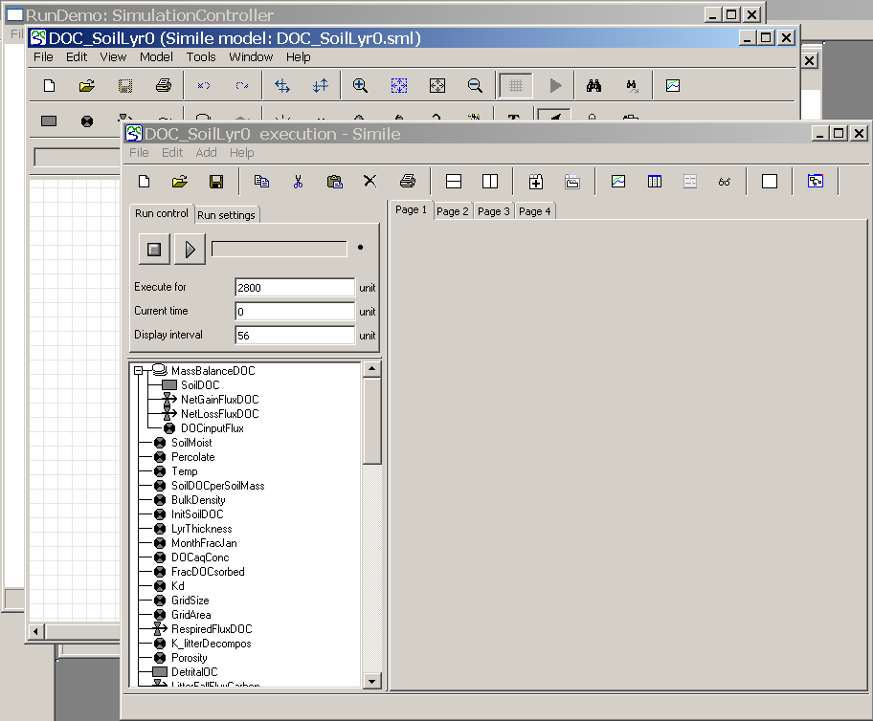
2. You can either call up the WaterChemistryModule after the DHSVM simulation completes at the end of specified period or at anytime during the DHSVM run. However, the time-series hydrologic data available to the WaterChemistryModule is from the first timestep until the date-time shown in the DHSVMModuleModule in VSB module.

3. Explore the model structure and parameters by switching from the Simulation Execution Window to the main Model Development window. The input variables are all listed on the left side of the page and the actual model flow diagram is towards the right side. To view equations for a particular variable or flow, double click on the variable names.
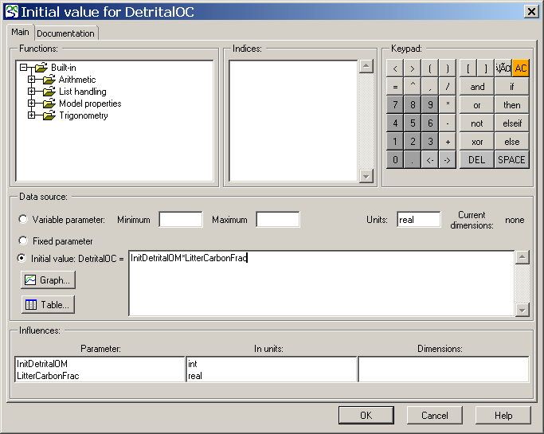

To view equations for all parameters in the model, go to Model → List Equations
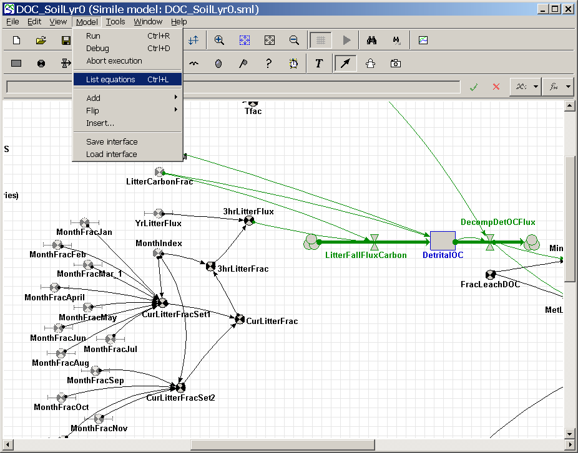

The Equation Listing will show up.
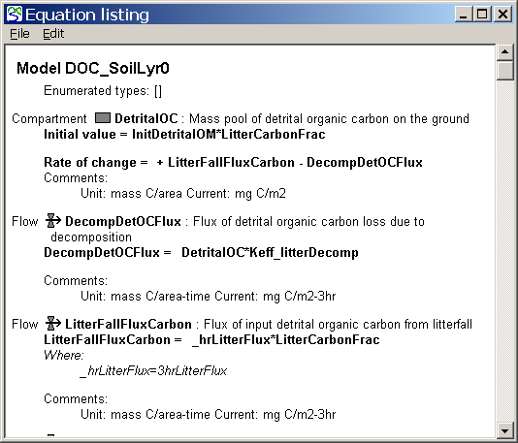

4. Specify or modify the values of input parameters. There are two types of parameters in this model.

4.1 Parameters that the value is already specified when building the model.
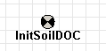

To modify the values, make change directly by double clicking on the variable and enter values or equations. Then, click 'save'.

4.2 Parameters that the values are given right before running the simulation. This method gives flexibility in swapping values of parameters based on scenarios. The variable symbol has a bar across it and it is referred to as 'Fixed parameter'.
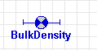

Currently, the model contains a set of fixed parameters. To view or modify the values, go back to Simulation Execution Window. Select File → Parameters

You will see a list of parameters, some with a single value (constant throughout simulation) and others with a series of values (time-dependent). These are hydrologic data and watershed attributes that are passed automatically from VSB into SIMILE.

For scenario analysis, you can change these values directly in this parameter dialog, and click OK. The values will be valid for the current run, but won't be saved if you close the Simulation Execution Window or quit the program. Alternatively, you can save a new set of parameter values by clicking the 'save' button and save the parameter set in a . spf file. Next time you want to load the values, open this 'File Parameter Dialog' and open the .spf file you saved.
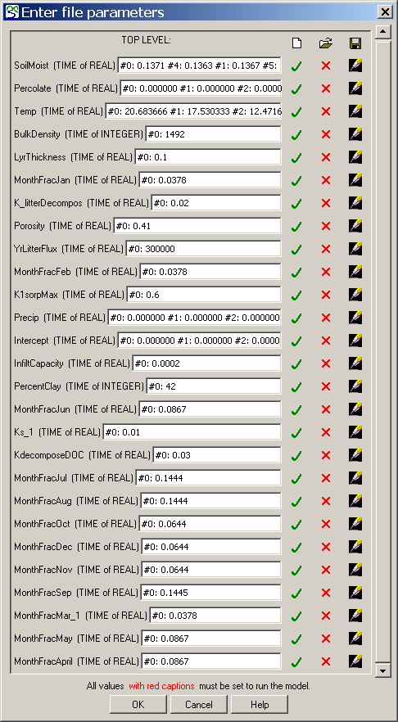
Time-series data
Constant value specified at time 0

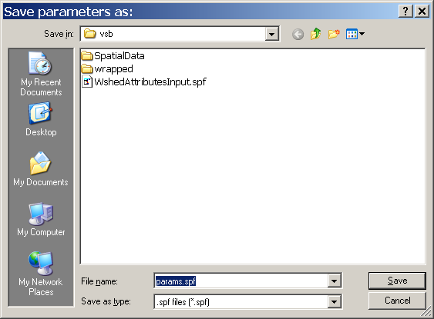

5. Outputs can be reported onto several pages. In the current page, set output format (graph or table) and select variables to be reported. Different formats can be used in different pages.
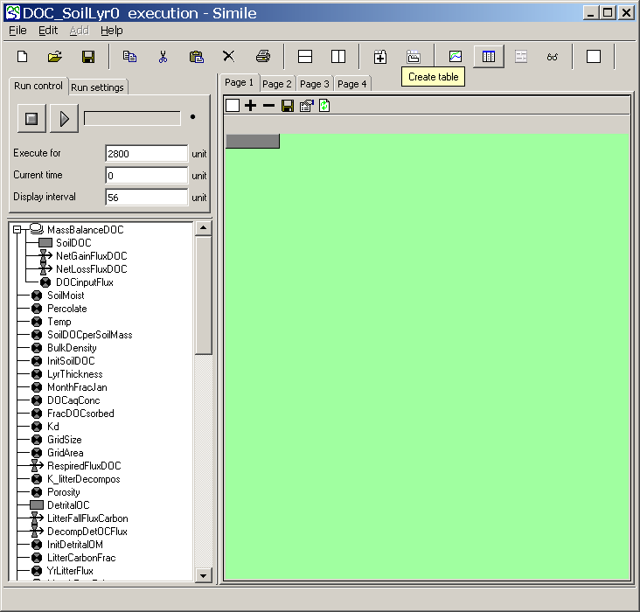

6. Set the Run control variables: Identify the number of time steps for the simulation. Be sure that this number doesn't exceed the number of steps of hydrology simulation in VSB. Set current time and display interval. For advanced setting, you can select the integration method of the differential equations in 'Run settings'.

Refer to Help in SIMILE or go to www.simulistics.com if you want to look up tips and tutorials.

