Laboratory Exercise 5:
Introduction to Virtual Scalable Basin (VSB)

Lab Objectives:
- Explore VSB as a framework for river basin modeling.
- Learn to use VSB to run a hydrologic model DHSVM & generate time-series stream flow and spatial output files for visualization using ArcGIS tools.

Background
So far you should have basic understanding of what makes up a watershed and river network. Today we will learn how to simulate hydrologic behaviors of a watershed using spatial information about the soil, vegetation, and topography and time-series meteorological data. The simulation will be done through Virtual Scalable Basin or VSB framework.

VSB applies a common philosophy to all river basin modeling such that input, process, and outputs can be standardized and solutions associated with the modeling effort can be reused across basins. In other words, several models can be linked together in a modular fashion and outputs from one model will be used as inputs for another.

Both hydrology and chemistry models are available through VSB. In this lab we are interested in the hydrologic simulation only. The hydrology model is Distributed Hydrology Soil Vegetation Model or DHSVM. Details on the model operation is in Wigmosta et al., 1994 paper. List of inputs and outputs are on the website at

http://www.hydro.washington.edu/Lettenmaier/Models/DHSVM/index.htm

Exploring VSB Interface

In this section, we will go through how to call up VSB interface, filling in GUI forms to run DHSVM, briefly look at the different input types, and run the model.

1. From Command Prompt, change directory to C:\vsb or other directory that vsb is in.
2. > python SimulationController.py
The GUI for VSB is displayed

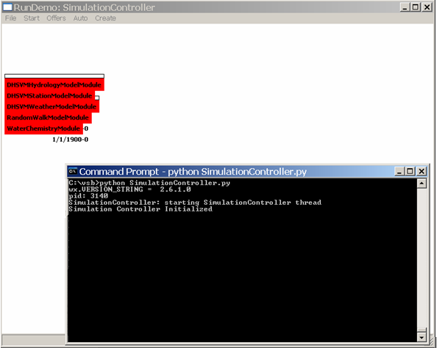

The five red module components shown are all available to the VSB framework. We are interested in DHSVMHydrologyModelModule, DHSVMStationModelModule and the WaterChemistryModule

3. Start by loading up the module map for our simulation. From the tool bar, select File → Load

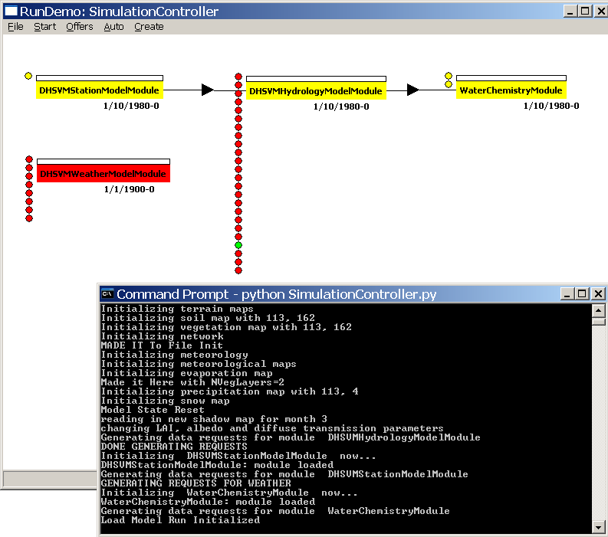

The GUI for modules is loaded. Relationships between modules are represented by arrows, indicating that the flow of data is sequential. The StationModelModule reads in meteoreological time series data from a station file, generate the weather data for the whole basin and feeds the HydrologyModelModule. Water balance is computed; pixel hydrologic outputs, along with soil and vegetation attributes are extracted then input to the WaterChemistryModule.

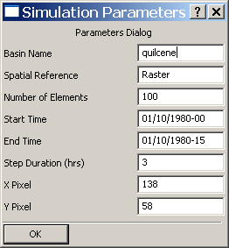
4. Next, set up information about the basin area and the time frame for simulation run. From the tool bar,
Start → Setup
-Enter the basin name in all lowercase letters
- Spatial Reference should be set to ‘Raster’
- Number of Elements is # of rows times # of columns.
- Select the start date/time, end date/time, and time step for
Simulation (American date format, MM/DD/YYYY-HH).
- Select the X,Y pixel coordinate you wish to use in the
Chemistry model (click on OK when done)

Note: the start date and time should be 01/10/1980 – 00 (the initial state files in database are set at this date and time). Then end time and date is flexible.

5. Load in input file(s) for StationModelModule. Right click on the left side of StationModelModule tab. The requirement dialog pops up, and we need to tell the VSB what format our station file is being provided in (click on the black button to the right of the filename).

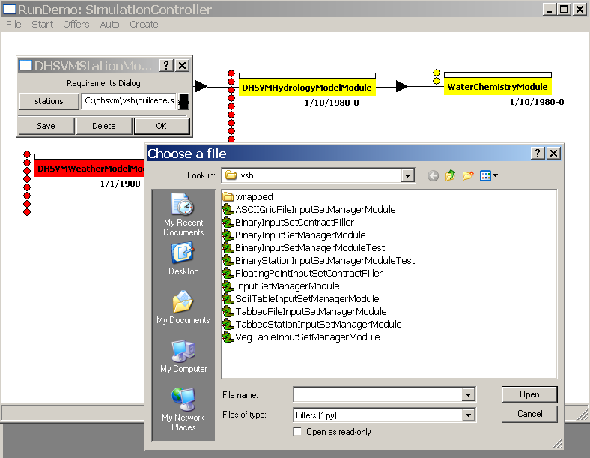

Choose the format named: TabbedStationInputSetManagerModule

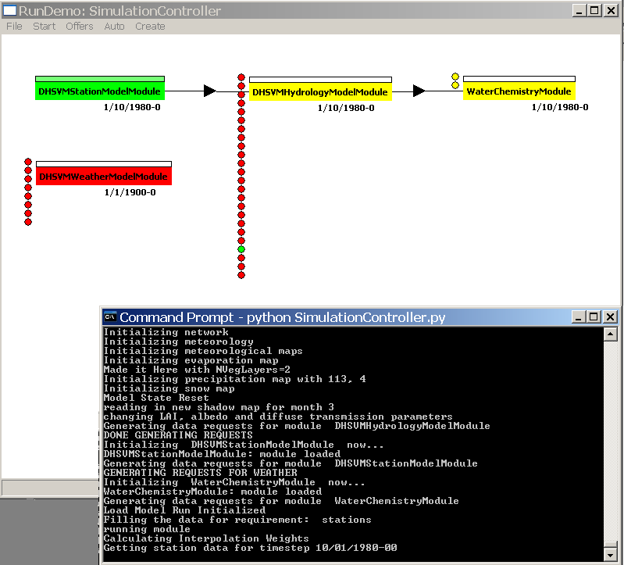

The DHSVM hydrology component starts getting its meteorological inputs from the DHSVMStationModelModule (red lights turn green for each input successfully loaded). Wait until the 9 weather related input lights turn green).

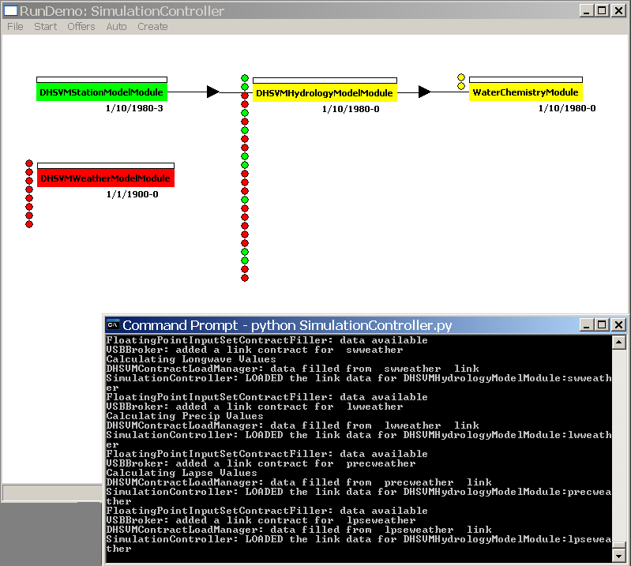

Note: In each "Requirements Dialog", if you make any changes to the file name/path and wish to save it, click "Save". Click "Ok" if you just want to view it and not save any changes.

6. Continue filling the hydrology module input requirements with data sets that are offered from the system. Choose Offers → Offers from the menu bar to activate the loading.

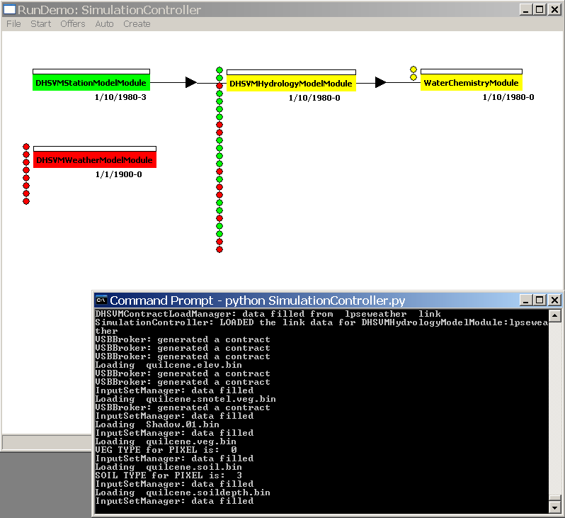

7. Two output files for stream flow information are generated in the VSB folder: Stream.Flow and Streamflow.Only. These are time-series data for specific stream segments of interest.

In addition, you can create an ASCIIGrid output for any of the DHSVM module variables on any time step (spatial data at a specific time). Just right mouse click on the DHSVMHydrologyModelModule component in the GUI, but on the right half of its visual component (the left half is inputs, the right half is outputs).

Put a filename into the appropriate field(s) you want ASCIIGrid raster output to be produced for the basin. The filename should end in .asc but call it what you want. It will be placed in the runtime directory (where SimulationController.py is) with the prefix: 1980m10d1h18 (year, then month (m), day (d), hour (h) ).

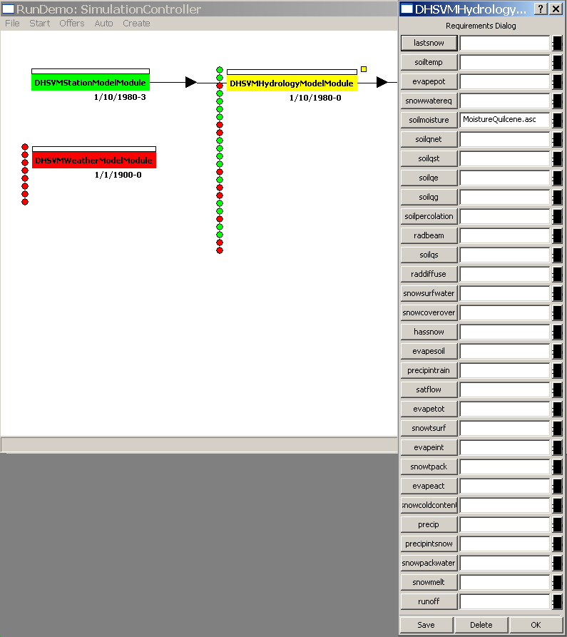

8. You can now auto run the simulation from start to finish. Your run will go straight through to the end date upon starting up the first time step. At the tool bar, select Auto → Fill.

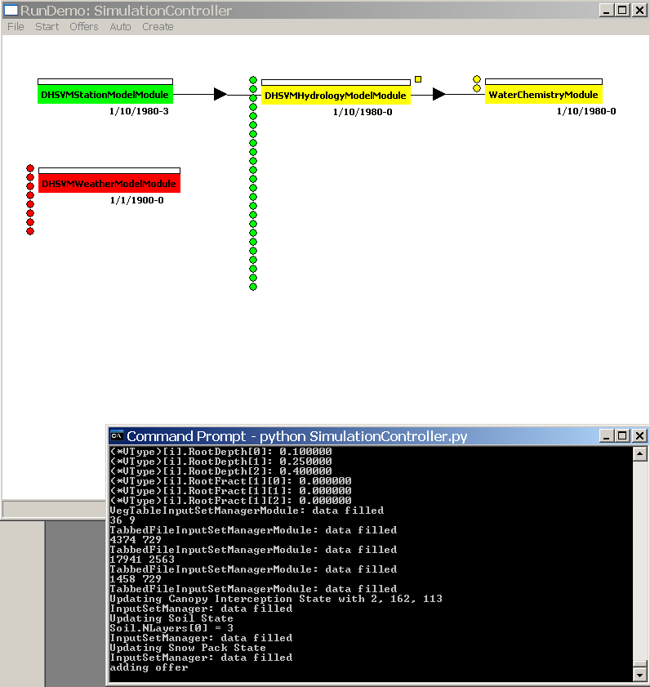

Now, all the necessary input requirements have been fulfilled (all input lights turn green).

Right mouse click on the left side of the module tab to bring up the Requirements Dialog, which you can review to confirm is filled with appropriate input file names. Click "OK" to accept those inputs and the simulation should proceed!

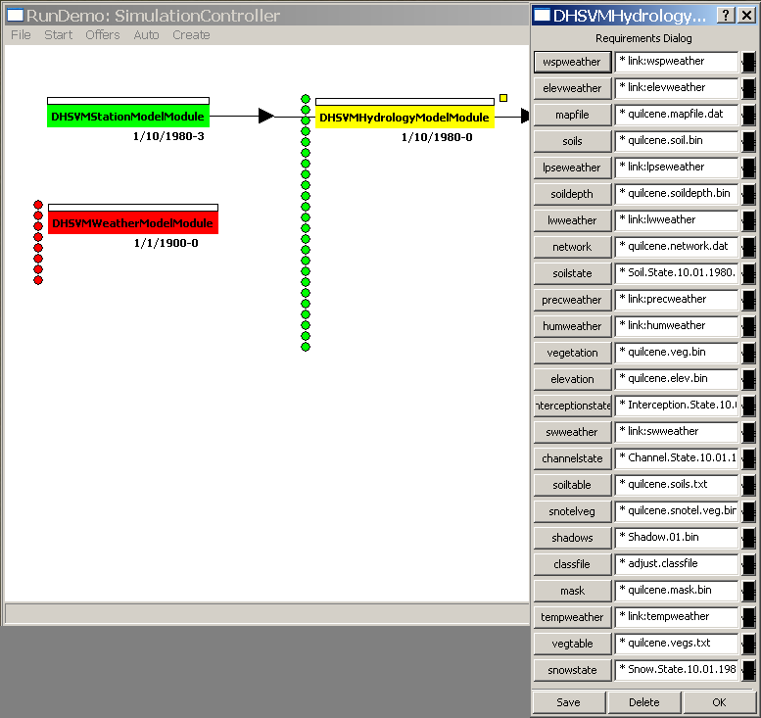

As the simulation goes on, you should see the date and time on each module changes.

9. Finally, call up the WaterChemistryModule with a right mouse click on the left side of the WaterChemistryModule tab. Its Requirement Dialog will pop up with the path of input files already filled in. Click OK to accept those.
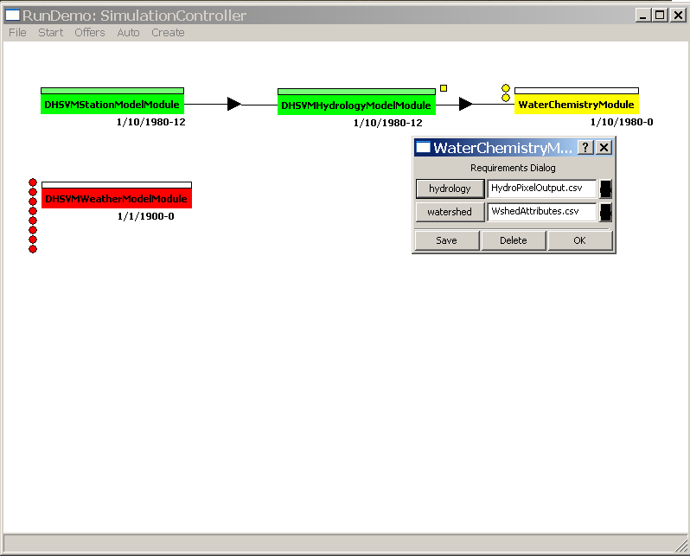

The SIMILE program will be launched and you will come to the GUI for water chemistry Simulation Execution Window.

The details on the chemistry model operation will be focused on Lab 6.

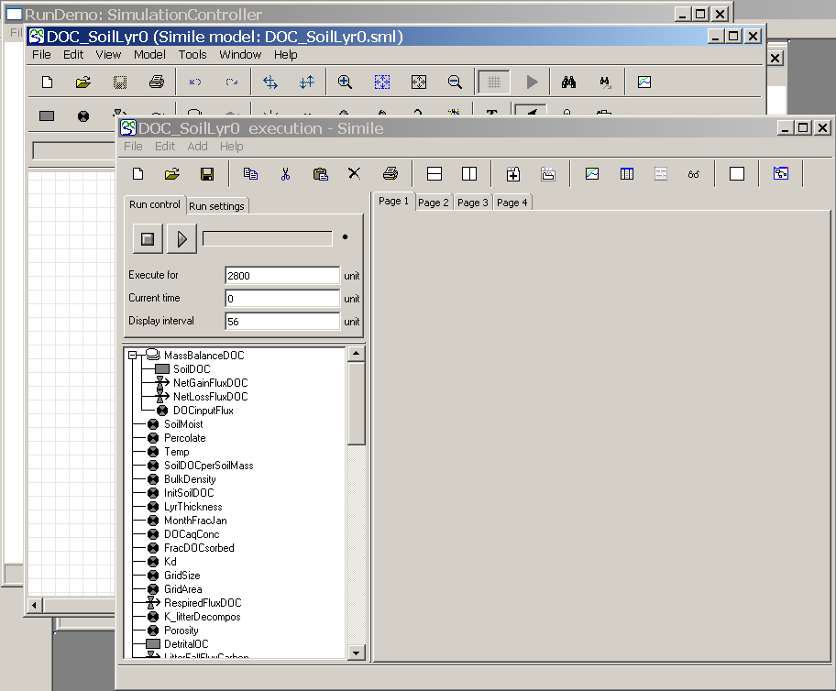

Note: At anytime, if you wish to terminate the VSB, use Ctrl + Break.

Exploring output at specific pixel location

You will notice that we have to specify a pixel location at the beginning of the VSB setup. This is because the soil chemistry model is for a specific grid cell in the basin. To view the values of hydrologic outputs for the interested cell directly, look at HydroPixelOutput.csv. To visualize the values of each parameter in relation to its neighbor or the whole watershed, we will locate the pixel in ArcMap.

1. Create a point file in .CSV format. In Excel, enter x and y as headers for longtitude and latitude coordinate respectively. On the row below, enter coordinate values.

In UTM coordinate, Northwest x = Extreme west + column number *Grid size (m) Northwest y = Extreme north – row number *Grid size (m)

For Quilcene basin, Extreme north = 5303895, Extreme west = 487815.

Alternatively, look at a map of elevation or some other raster data in ArcMap and use Identify tool to browse on the map and get the desired coordinate.
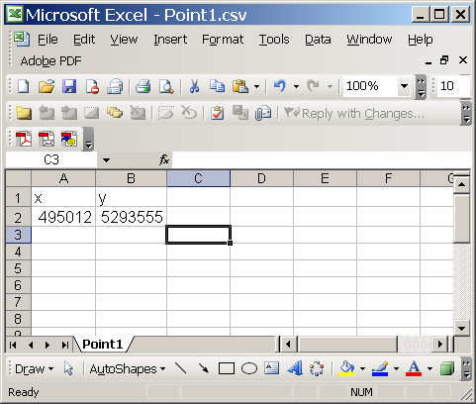

Save the file as .CSV and close it.

2. In ArcMap → ArcToolbox, select Layers and Table Views → Make XY Event Layer
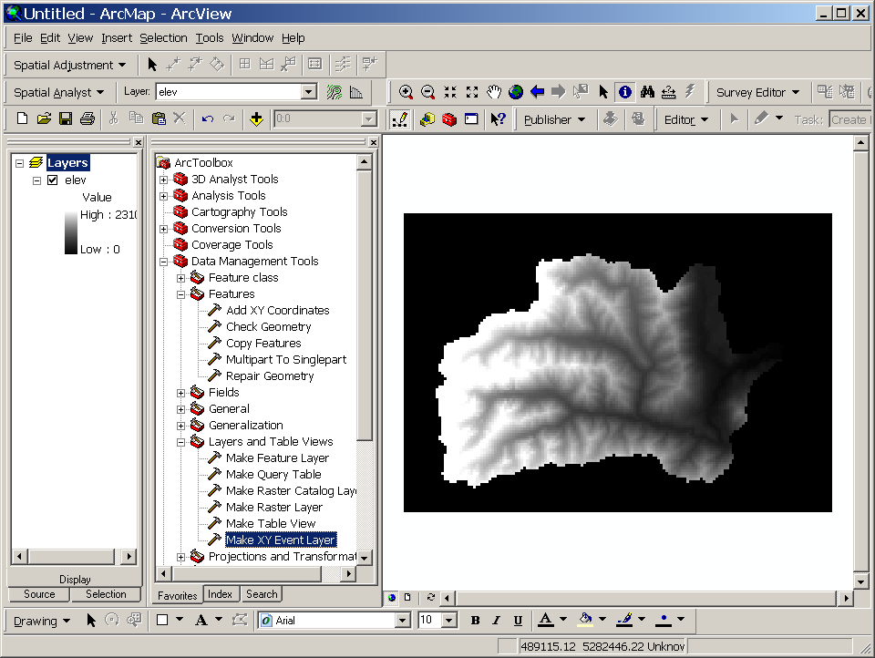

3. In the 'XY Table' tab, enter the name of the .CSV point file we just created, x and y fields, and the name of the output point layer.

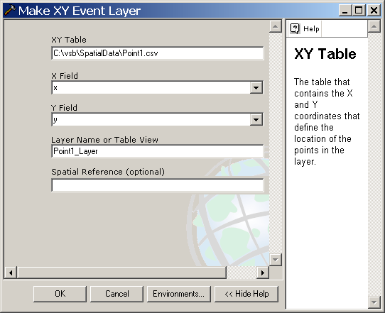

4. Now you have a point coverage of pixel location.
