Laboratory Exercise 4:
Introduction to Geoprocessing in ArcGIS

Lab Objectives:
- Learn to use Model Builder to create a simple erosion model
- Learn to use ArcScene to visualize the results

Background

Today’s lab will introduce you to a more advanced method of using the tools in ArcToolbox. Rather than working with each tool one-at-a-time, we will make a model that executes several tools in sequence to produce a final result. The advantage of doing this is that we can store our model for the future. We can adjust the model parameters and re-run the model without going through each step again.

The erosion model that we will use is based on a paper by Finlayson and Montgomery (2003). The model is designed to identify where in a landscape fluvial erosion is likely to be greatest based only on the drainage area and slope.

The Stream Power Law of Erosion

The stream power law of erosion is:

$$\overset{˙}{ε}={\text{kA}}^{m}S^{n}$$
where $\overset{˙}{ε}$ is the incision rate, A is drainage area, S is slope and k, m and n are constants. This law states that the river incision rate is proportional to the product of drainage area and slope. In other words, the steeper a terrain and the bigger the river, the more erosion it should casue.

The constants m and n control the relative importance of drainage area versus slope. They typically range from 0.5 to 1.0. The constant k controls the proportionality between incision rate and the stream power formula. It is highly dependent on the physical properties of the landscape and soils through which the river is moving. It needs to be determined independently for each landscape. This is an ambitious task. However, if we only want to identify locations in the landscape where erosion is most likely to occur, we need only identify where stream power is large and where it is small. In this case we don’t need the proportionality k. We can rewrite the equation as follows (using values of m and n for a shear-stressed based model):

$$\frac{\overset{˙}{ε}}{k}=A^{0\text{.}5}S^{0\text{.}\text{67}}$$
Here, A^{0.5}S^{0.67} is known as the Erosion Index, or EI for short. We are going to implement the EI for the Quilocene river basin.

Setting Up ArcMap
Load a new ArcMap project with just the dem_clean and dem_area datasets. Turn on ArcToolbox by clicking on the red toolbox icon. If the Spatial Analyst toolbox is not present, add that toolbox following the directions from Lab 3.

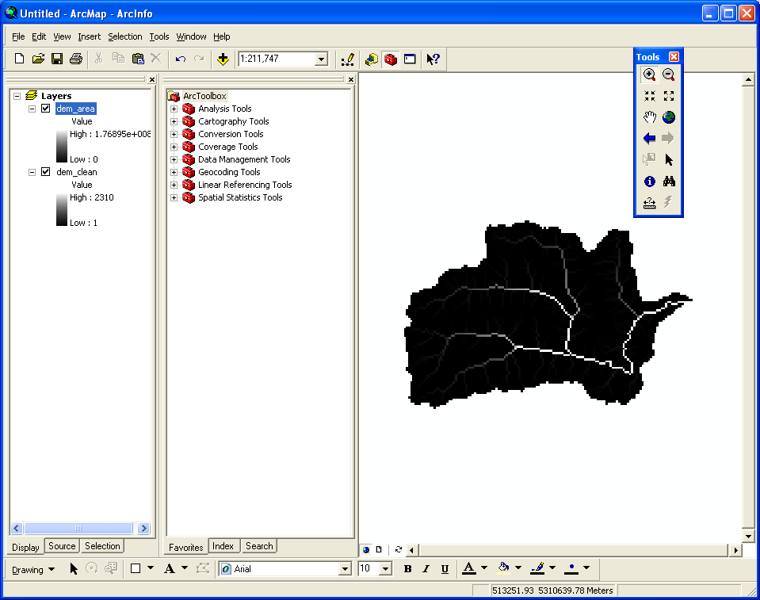

Right-click on an empty part of ArcToolbox and set up the Environment so that the Current and Scratch Workspace are set to your working directory. Click OK.

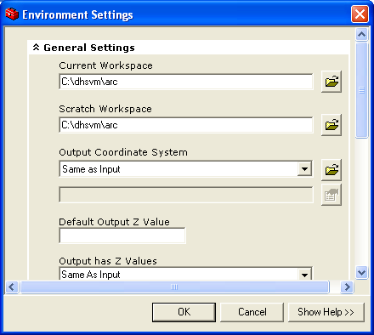

Creating our own Toolbox

Next we need to create our own toolbox. This toolbox will hold the EI model. Right-Click on an empty part of ArcToolbox and Select New Toolbox.

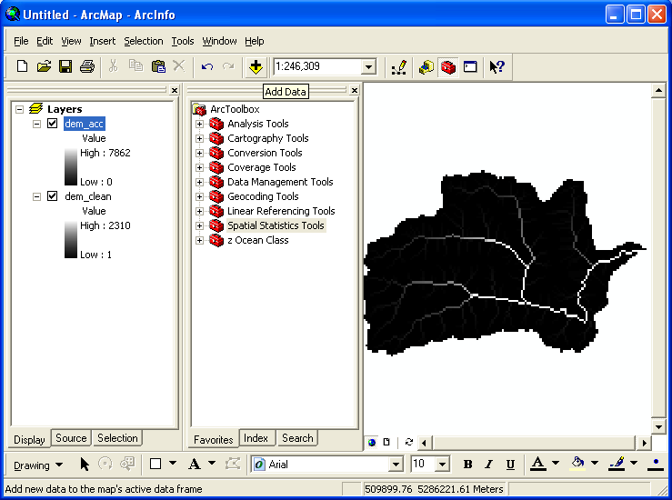

I called mine “Ocean Class”. (I put the z in there so it sorts down to the bottom of the list).

Next we will add an empty model to our new toolbox. Right-Click on your toolbox and select New > Model. This will bring up an empty Model window:

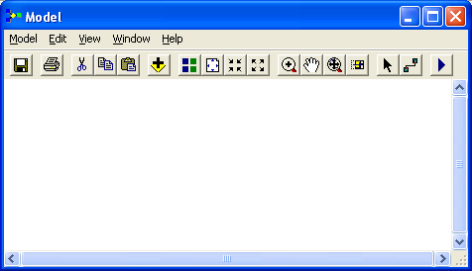
The first step to building a model is to fill out some metadata about what to call the model and what it does. From the menu, select Model > Model Properties. Fill out the boxes as shown in the figure below:

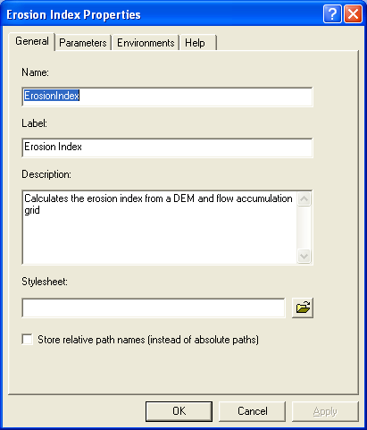

The Name of the model should be: ErosionIndex (No Spaces Here!). The Label for the model is Erosion Index (spaces OK here). Models can be called from the commandline using the Name property. The command line doesn’t allow for spaces in names (hence we have a Label that is more user-friendly for the GUI).

Click OK.

Arrange your screen so that you can see both the ArcToolbox tools and the empty Model.

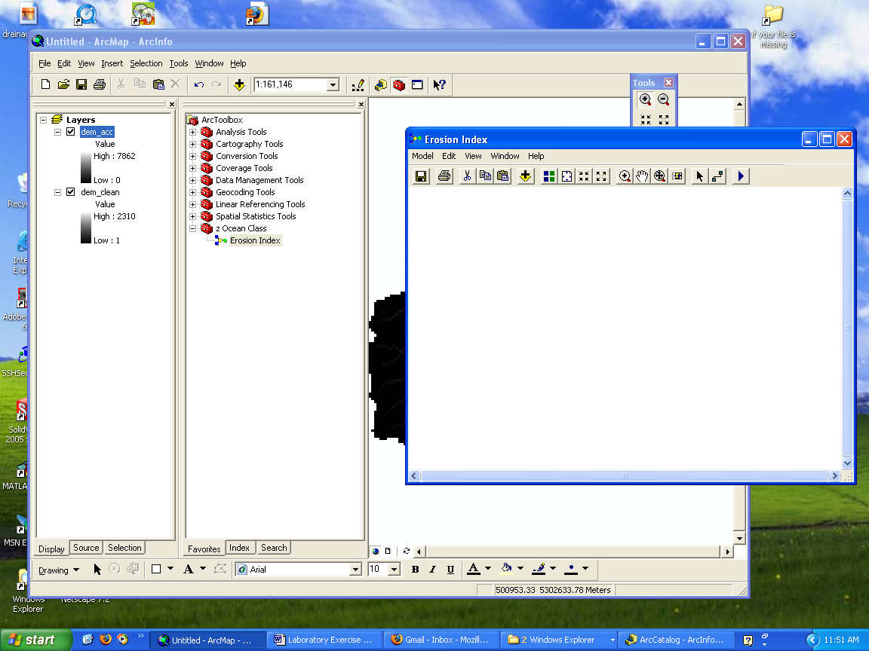

We proceed by building up the EI equation one piece at a time. The first part is to raise drainage area to the power 0.5. Drag the dem_area raster from the table of contents to the model as shown:

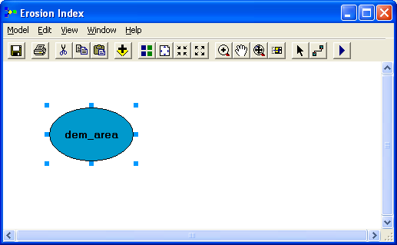
Next, drag the Pow function from ArcToolbox:

ArcToolbox > Spatial Analyst Tools > Math > Power

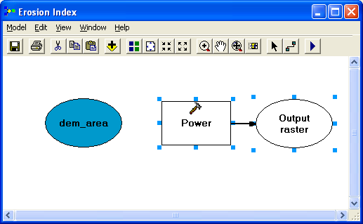

Now select the Connector tool (circled above) and connect (draw a line between) the dem_area bubble to the Power box.

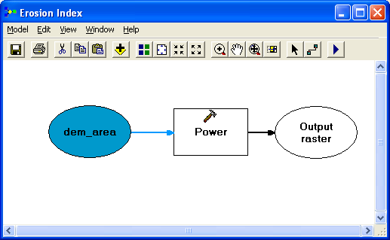

Next, Double-Click on the Power box to open the Power Dialog:

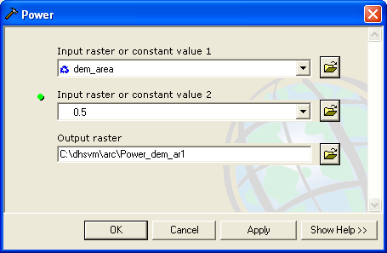
Notice that the Input raster has been set to dem_area for us. We need to fill in the power 0.5 in the second box as shown. Click OK.

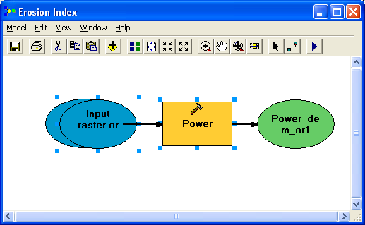
You will now see that the Power box has been colored in yellow. This indicates that all of the requirements for this command have been satisfied. You should also see a second bubble has appeared called Input raster or (Not a very good name). This second bubble is the exponent 0.5 we just entered. You can use the Arrow tool to move the bubbles around, or you can click on the circled icon to auto-format the box.
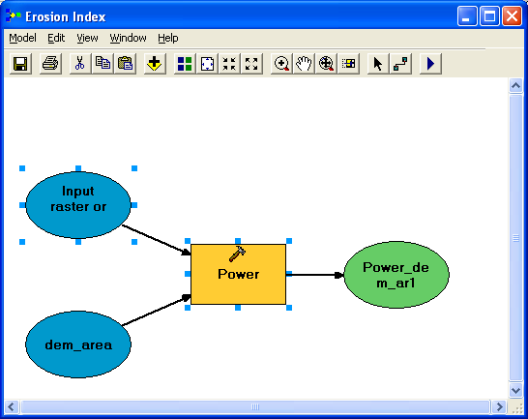
By Right-Clicking on the Input raster or bubble and selecting rename, we can rename it to something more sensible like “area exponent”. We can do the same for the green output raster which I have called temp1.
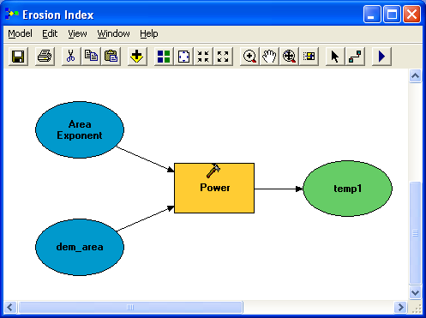
So far so good. Now we need to create a Slope grid from dem_clean. Drag dem_clean and the Slope tool (ArcToolbox > Spatial Analyst Tools > Surface > Slope) into the model and connect them as shown using the connection tool.

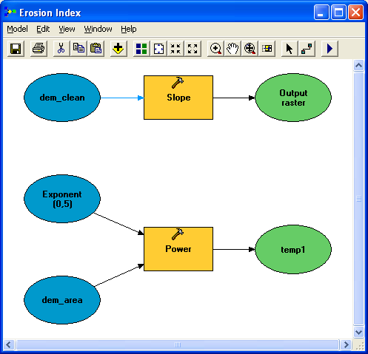
The slope tool only needs 1 input so as soon as you link dem_clean to the slope tool it will color itself in. However, the default slope result is in degrees and we need the result in the form rise over run (y/x). We can achieve this by changing the Output measurement from DEGREES to PERCENT RISE and then changing the Z-factor to 0.01 (to convert from percent back to a simple fraction):

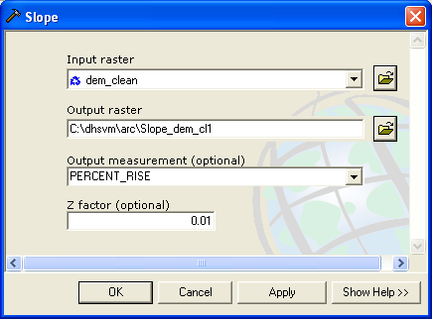
Click OK. Rename the output raster to dem_slope as I have done below:
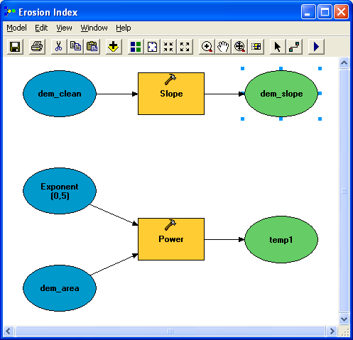
Now drag another Power tool onto the model and raise dem_slope to the 2/3 power (0.67). Rename the output to temp2:
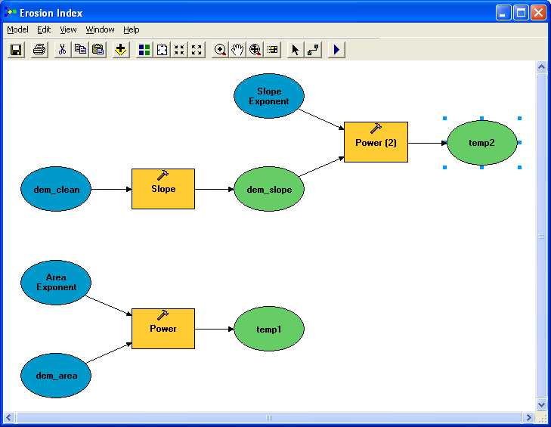

The last part of the model is multiplying temp1 by temp2 using the Times tool. Drag the Times tool (Arctoolbox > Spatial Analyst Tools > Math > Times) onto the model and then connect both temp1 and temp2 to the Times box. Rename the output to Erosion Index.

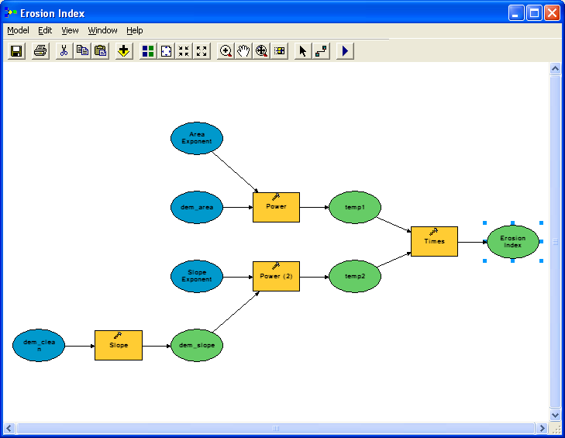
Now we will go through the green output rasters and make sure these are set up properly. First, right-click on the green dem_slope bubble and uncheck Intermediate and check Add to Display. This is not a temporary result that we want erased. Next double-click on the dem_slope bubble to bring up its dialog. Set the output path to your working directory and call the output dem_clean as shown. Click OK.

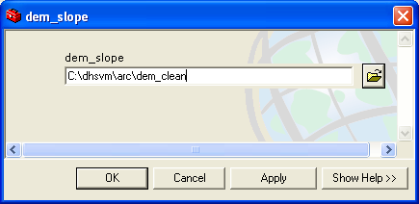

The two temporary grids temp1 and temp2 are Intermediate results that we do not want to keep. Right-click on each of these bubbles and make sure that Intermediate is checked and Add to display is unchecked. Finally, Erosion Index is a permanent result. Uncheck Intermediate on the Erosion Index bubble, check Add to Display and set its output name to dem_ei as shown:

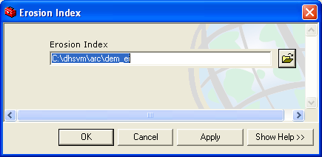

Save your model (Model > Save).

To execute the model click the “Play” button circled below. You should see the model execute each tool in turn and add dem_slope and dem_ei to ArcMap:

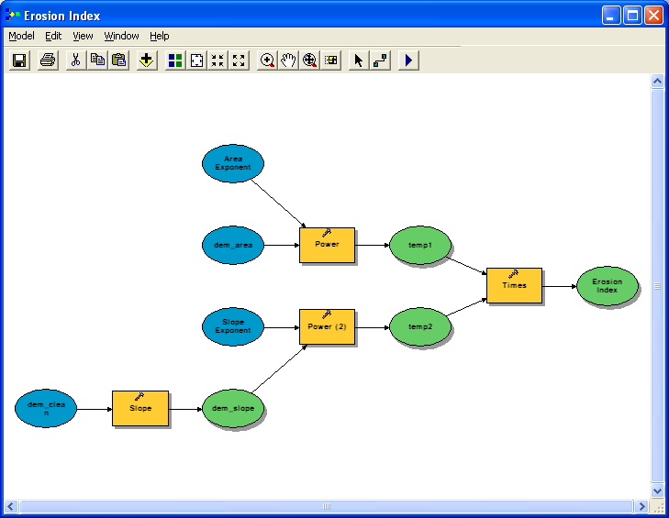

The results (after working with the color ramp are shown below):

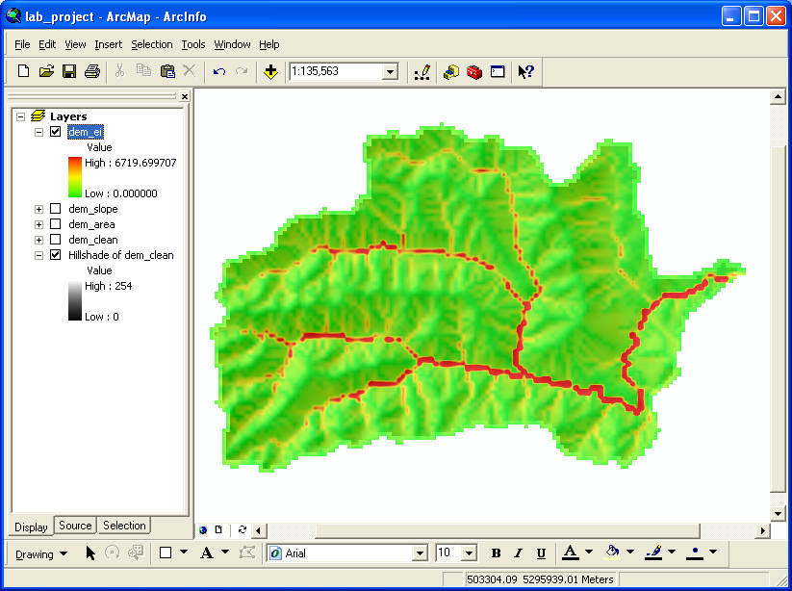
The model that we used had exponents m=0.5, n=2/3. This is known as the “shear-stress” variation of the stream power law. Other variations such as m=n=1 (Total Stream Power) and m=1/2, n=1 (Unit stream power) change the picture somewhat. Try them out by editing the model (Right-Click on the Erosion Index Model and select Edit) and changing the exponents.

To erase the intermediate files (temp1 and temp2) from the Menu select Model > Delete Intermediate Data. You will need to rename the output files (the model won’t over-write existing files) or delete them (use ArcCatelog) prior to running the model a second time.

Can you think of a way to incorporate the soil and vegetation data layers we have for this watershed to create an improved erosion index?

