Laboratory Exercise 3:
Introduction to Hydrologic Modeling in ArcGIS

Lab Objectives:
- Learn to use rasters for modeling a hydrologic network
- Learn to build a model in ArcToolbox

Background

Today’s lab will introduce you to a few of the basic hydrologic modeling features in ArcGIS. Before beginning, take a few minutes to read over the help files that introduce the Hydrologic Modeling functions (from ArcMap):

Help > Spatial Analyst > Map Algebra and ArcObjects Functional Reference > Hydrology tools > An overview of the Hydrology tools

Setting up ArcMap for Analysis
Load the elevation data set into a new ArcMap document.

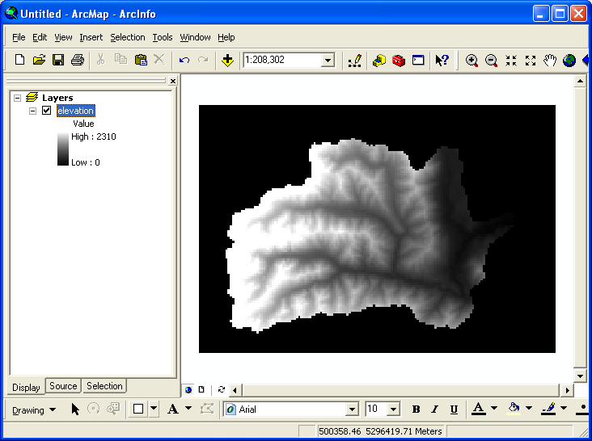

Click the ArcToolbox Icon so that the ArcToolbox is visible (you can dock it the way I have shown by dragging it until it attaches itself to the side):

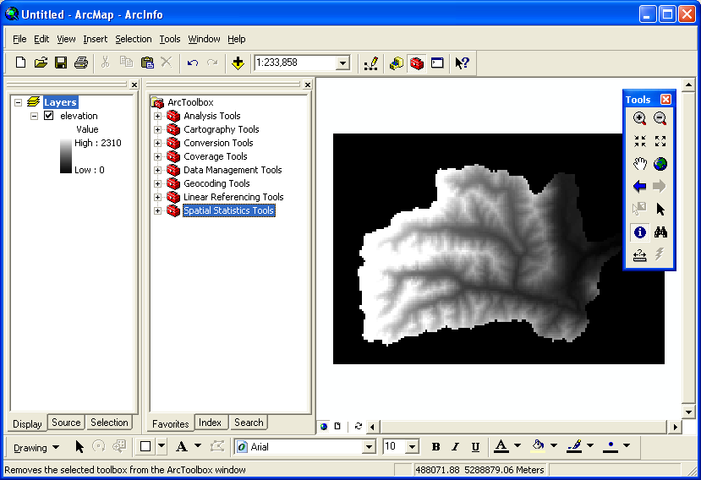
Next, we will add the Spatial Analyst toolbox to the ArcToolbox pane.

Right-Click in a blank area of the ArcToolbox pane and Select Add Toolbox

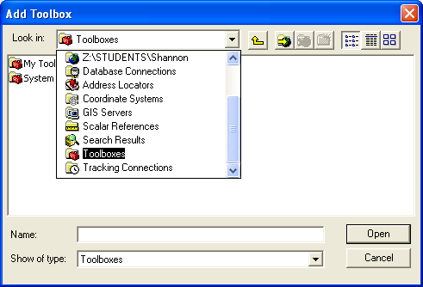
Use the Look in: Drop-down and scroll to the bottom to see Toolboxes.

Then Select System Toolboxes > Spatial Analyst Tools

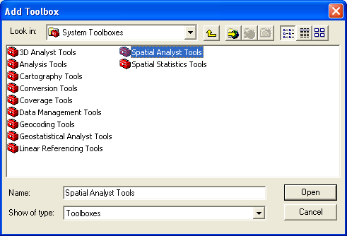
Click Open. You should now see the Spatial Analyst toolbox in ArcMap:

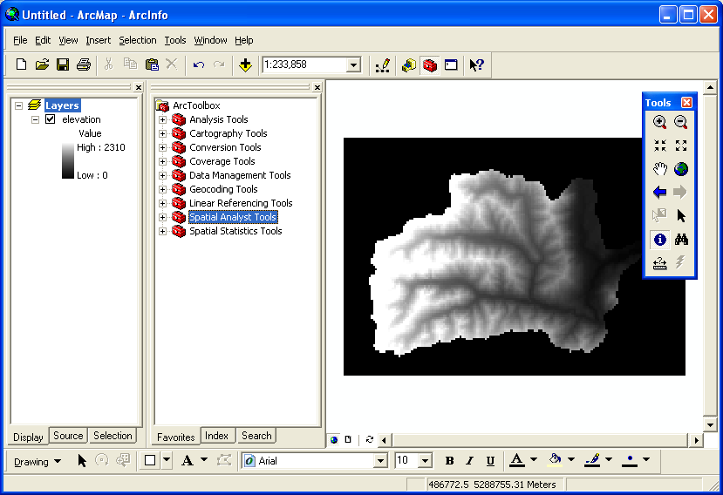
The next step is to setup our analysis environment. Right-Click again in a blank area of ArcToolbox. This time select Environments. You will see Environment Settings dialog:

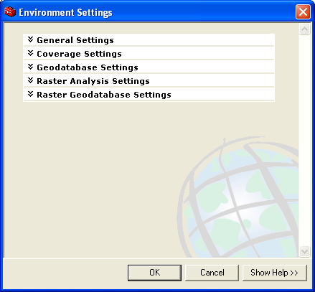
Expand the General Settings category and set the Current Workspace and the Scratch Workspace to your working directory:

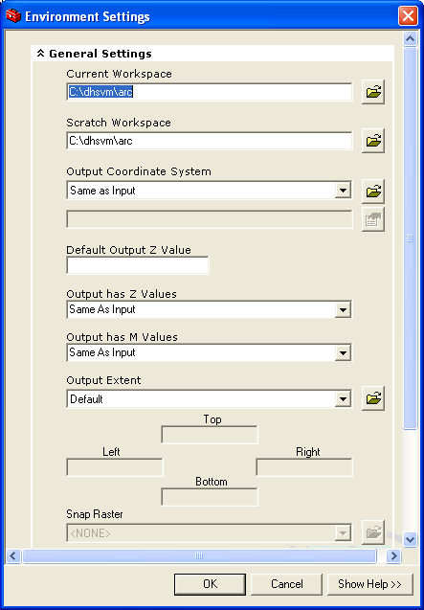
Click OK. The rest of the values can be left to their defaults.

Step 1: Setting the “Collar” cells to NODATA

Notice that the elevation DEM only has elevation values to represent the watershed; outside the watershed, the values are set to 0 (You can verify this with the Identify tool):

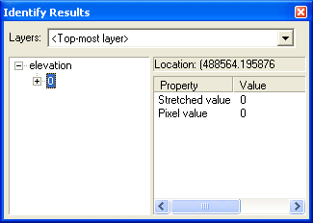
The Value = 0 is being used here to represent No Data. In ArcGIS, the proper way to represent No Data is with a special value called NODATA.
Our first step to cleaning this DEM is to set the Zero values in elevation to NODATA. To do this, we will need to use the CON tool. Open the CON wizard in ArcToolbox:

ArcToolbox > Spatial Analyst tools > Conditional > Con

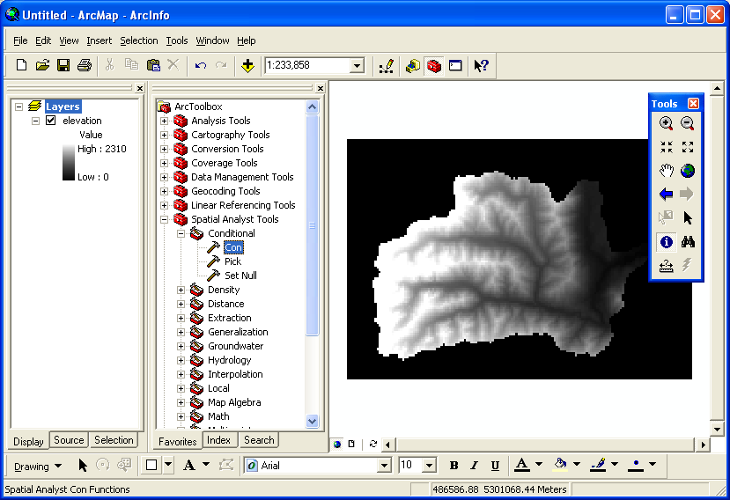

This will bring up the CON wizard (short for CONDITION):

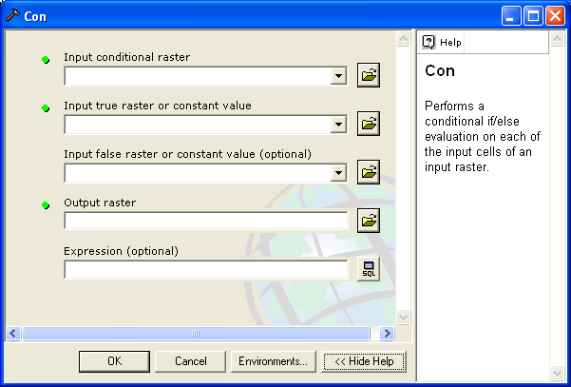

Click the Show Help>> button to see a brief description of the command. Set the following:
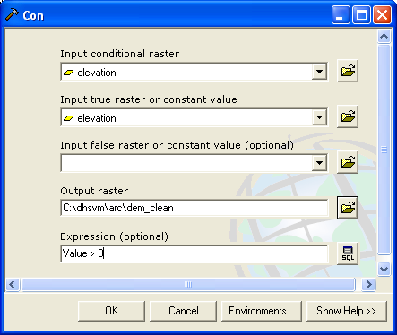
In English, the Input conditional raster is the grid against which we run the Expression. In this case we are saying, use raster elevation, if its Value is greater than 0 then put in the value in elevation, if the Value is not greater than 0, then do nothing (nothing in this case means put in the value NODATA).

Here is another way to think of it if you know a little programming pseudo-code:

If elevation.Value == 0
Then
Result = elevation
Else
Result = NODATA

The Output Raster should be called dem_clean but make sure the path leads to your working directory.

Click OK to run the command. You should now see a new raster called dem_clean. Our new DEM has NODATA around the margins of the watershed instead of the Value == 0.

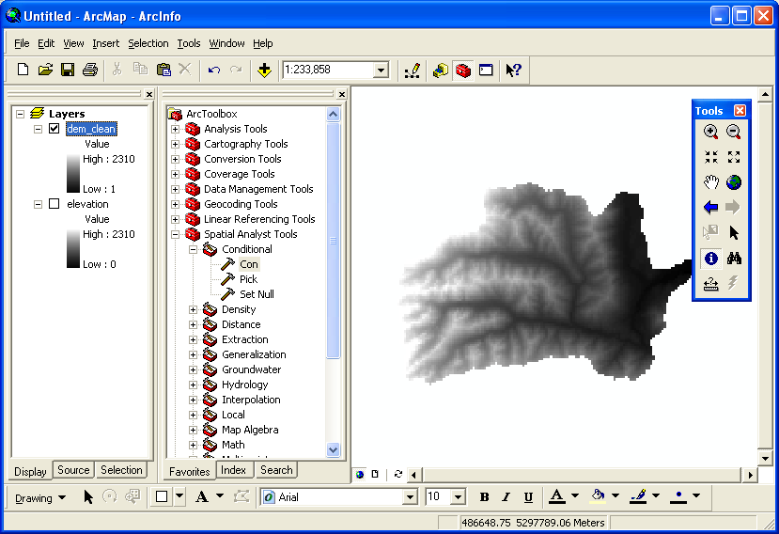

Step 2: Correcting Errors in the DEM
Most digital elevation models (DEM) cannot be used directly to model river networks because they contain peaks and sinks that interrupt the flow routing in the hydrologic model (see the help file above if this is confusing terminology). To remove these anomalous cells from the DEM we “Fill” the DEM.

From ArcToolbox Select:

Spatial Analyst Tools > Hydrology > Fill

This will bring up the Fill command wizard:

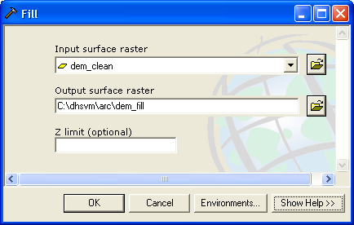

Set the Input surface raster to dem_clean and the Output surface raster to dem_fill (remember to set the proper path to your working directory not mine). Click OK. This will add a third DEM to our map called dem_fill. This DEM has no sinks or peaks in it that will interrupt flow routing.

Step 3: Calculating Flow Direction

Now that we have a “filled” DEM, we can determine the direction water would flow from each cell in the raster. Use the Flow Direction tool:

ArcToolbox > Spatial Analyst Tools > Hydrology > Flow Direction

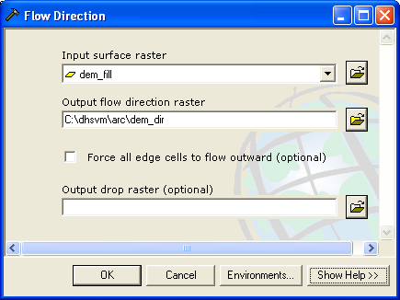
Set the Input surface raster to our “filled” dem dem_fill and the Output flow direction raster to dem_dir. Click OK.

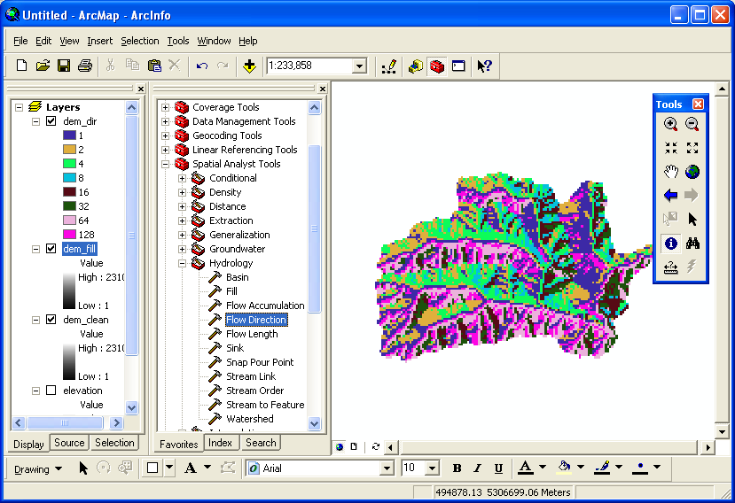
The new raster dem_dir contains 8 codes 1,2,4,…,128 that identify the direction water would flow from the center of each cell. There is a nice explanation of the procedure here:

Help > Geoprocessing (including ArcToolbox) > Geoprocessing tool reference > Spatial Analyst toolbox > Hydrology toolset > Determining flow direction

Step 4: Calculating Flow Accumulation
The Flow Accumulation function uses the flow direction raster we just calculated to route water downhill. Each cell is assigned a weight of 1 (initially) and this value is given to the next downstream neighbor which now has a value of 2. This cell now assigns its value to the next downstream neighbor which now has a value of 3, and so on until all of the cells have been processed. The result is that each cell in the flow accumulation raster has a value equal to the number of cells upstream. Again, the help files have a nice explanation:

Help > Geoprocessing (including ArcToolbox) > Geoprocessing tool reference > Spatial Analyst toolbox > Hydrology toolset > Calculating flow accumulation

To activate the Flow Accumulation tool:

ArcToolbox > Spatial Analyst Tools > Hydrology > Flow Accumulation

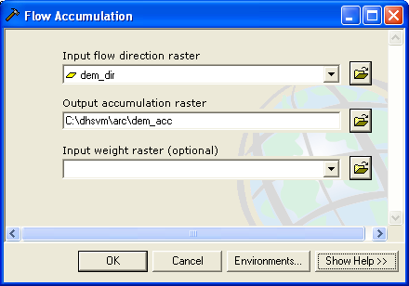
The input flow direction raster should be dem_dir and the Output accumulation raster dem_acc.

Click OK.

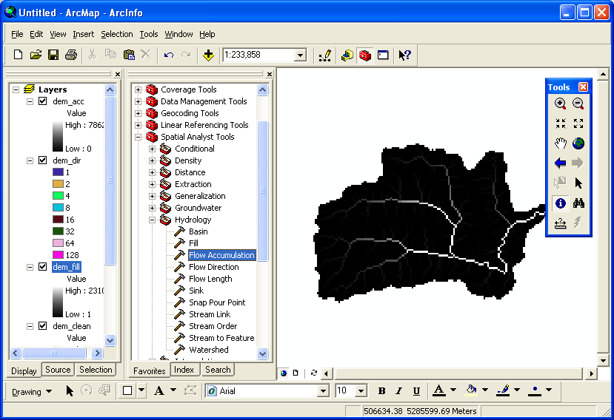
The new raster dem_acc clearly shows the dendritic drainage pattern of the basin. The Value of dem_acc is the number of upstream cells. Use the identify tool to click on and off the “stream” and also work your way upstream, you will see the number of upstream cells decrease exponentially until you reach a ridge.

Instead of working with # of cells as a value, we can convert the units to drainage area by multiplying dem_acc by the cell area. In other words:

Drainage area = # of cells * area of cell

Each cell is 150 m by 150 m or 22500 m². So to convert dem_acc to dem_area:

ArcToolbox > Spatial Analyst Tools > Math > Times

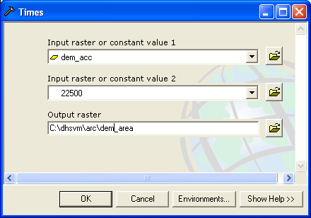
This gives us the drainage area of each cell in the DEM:

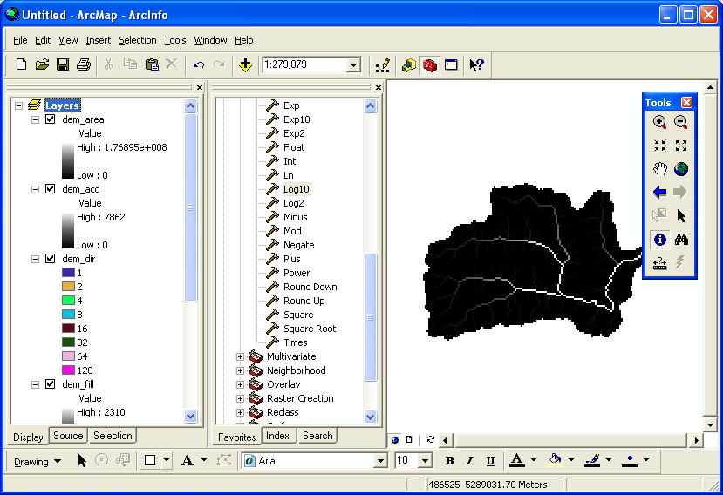
Since drainage area is an exponential phenomena (each branch of the stream increases the drainage area exponentially) and drainage area values are very large (1.7x10⁸ m² is the largest drainage area in our watershed), it makes since to take the logarithm base 10 of the drainage area and work with drainage area in Orders of Magnitude:

ArcToolbox > Spatial Analyst Tools > Math > Log10

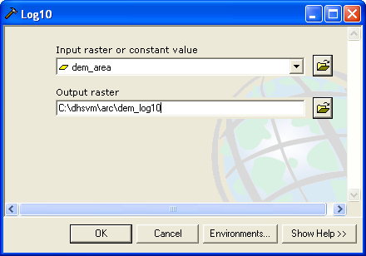
This produces a new raster dem_log10 that has the drainage area represented in log₁₀ m². Now the numbers range from 4.4 to 8.2 (10^{4.3} to 10^{8.2}). If you change the color scheme a bit, you can really pull out the drainage network:

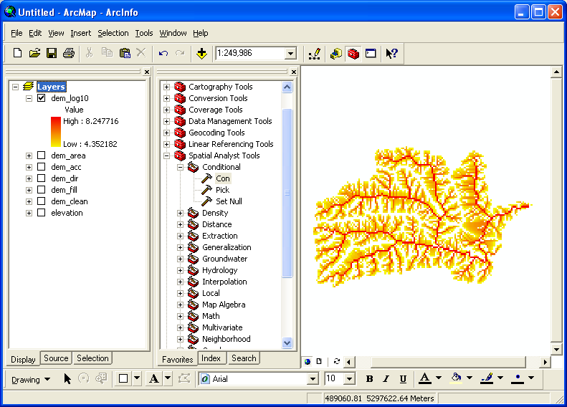

Step 5: Extracting the Stream Network

So far, every cell in dem_log10 has a drainage area except the ridge cells---cells without upstream neighbors. We have not yet defined what is the minimum drainage area required to form a stream. This is a research question. Where do streams begin? The answer depends on a large number of physical factors which we will not address formally here. Let’s assume two things:

- Every cell in the drainage basin contributes equally to overland flow
- A drainage area of 10⁷ m² is sufficient to generate enough water for a perennial stream.

We made assumption 1 when we calculated the flow accumulation without a weight grid (go back and look at the help for the flow accumulation dialog). We could have had different weights for each cell so that parts of the watershed contribute more water than others to the network. The second assumption we will make in the next step when we extract the river from the drainage network.

Reload the Con tool:

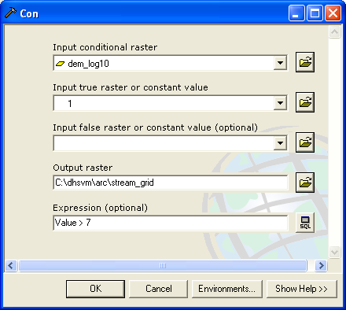
This time the Input conditional raster is dem_log10 and the Expression is Value > 7. If this condition is true we have a stream, set the Output, stream_grid, Value = 1, otherwise do nothing (set to NODATA).

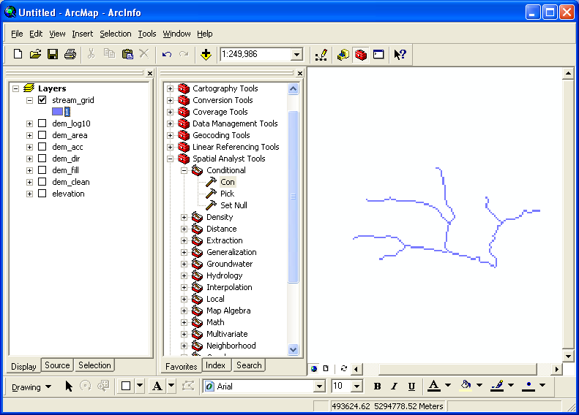
stream_grid has a Value = 1 in every cell that is a river and NODATA everywhere else. With stream_grid, we can calculate the STRAHLER and SHREVE stream order using the Stream Order Tool:
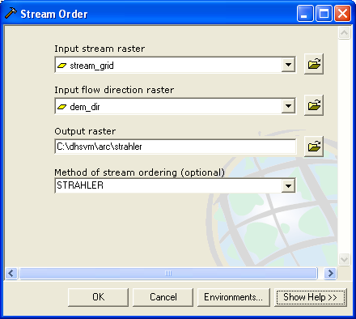

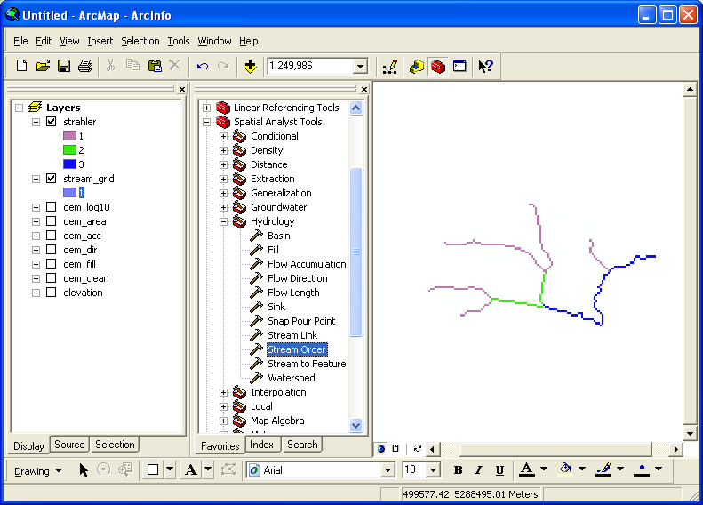
Can you figure out the difference between STRAHLER and SHREVE ordering schemes (both are common)?

We can also use stream_grid to convert the raster stream network to a vector representation using the Stream to Feature tool. This converts the stream_grid to streams.shp. Streams.shp is a shape file. Shape files are a common vector format used in ArcGIS.

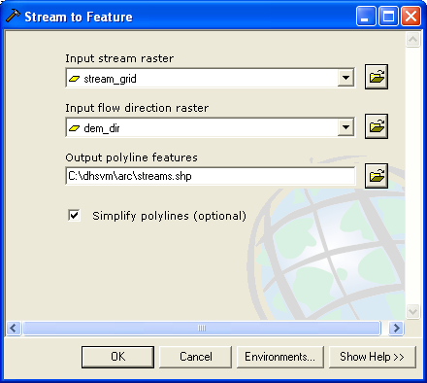
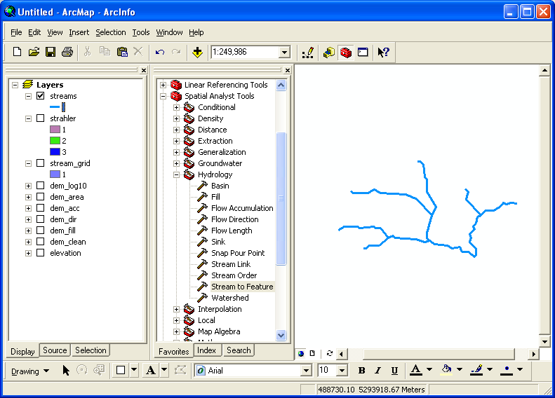
Notice that vector lines have different symbology options than raster lines. We can symbolize the stream network using bold lines and strong colors that would be difficult to implement in a raster representation. Vectors also naturally break the stream into distinct segments. This is an advantage when the stream is converted to a network (think of pipes) and flow must be routed through the channel segments where each segment takes on certain hydrodynamic characteristics. The DHSVM hydro model used later in the course represents the stream network as a series of connected segments that were originally derived from a vector representation of the stream. The vector network was created in a similar way to the procedures outlined here.

Presenting the Results

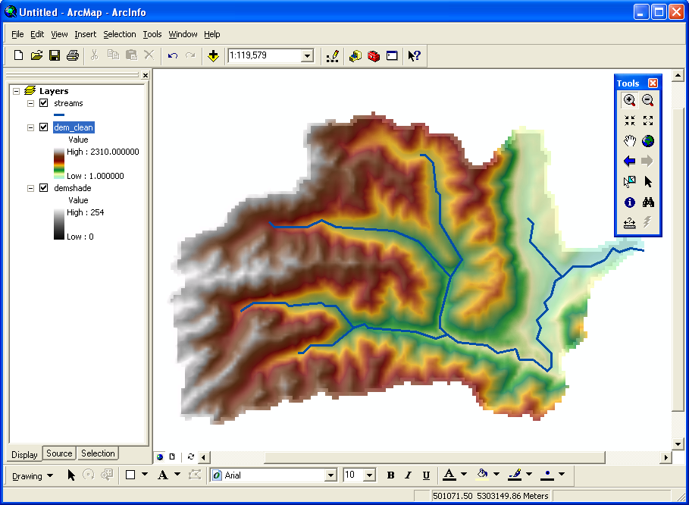

For this map, I created a hillshade map of the dem_clean raster and put that at the bottom of the stack. I then colored the dem_clean raster using a nice color ramp that looks a bit natural for mountainous terrains. I put this coverage next on the stack and made it about 30% transparent so the hillshade shows through a bit. Finally, I put the streams vector on top, made it a bit thicker and changed the color to dark blue. Then I exported the results as a JPG file. You should be able to do all of this now yourself.

