Laboratory Exercise 1: Introduction to ArcCatelog

Lab Objectives:
- Learn how to use the ArcCatelog to import data into ArcGIS
- Learn how to use ArcToolbox dialogs
- Learn how to assign a projection to data

Background
In order to get the most from this lab (and this class) it is important that you have a basic understanding of GIS terminology. ArcGIS comes with a powerful and very well written help facility. If you are not familiar with raster processing in ArcGIS, I recommend that you start the lab by Opening ArcGIS Desktop Help and reading (at least) the following nodes:

Extensions > Spatial Analyst > Getting Started with Spatial Analyst (skip the table)
Extensions > Spatial Analyst > Understanding raster data (read all of the sub-nodes)

Be sure that you understand the following terms and concepts:
- What is the relationship between a cell and a raster?
- What is the difference between the row and column numbers and the geographic coordinates of a cell?
- How does a raster represent elevation? A geologic map or vegetation type? A stream?

Importing Raster Data
The raster data used in this exercise is in a generic format known as ESRI ASCII Grid. This is a very simple format that is easy to work with for both GIS users and modelers. In this section you will learn how to import ESRI ASCII Grids into ArcGIS.

Step 1: Create working directory for your project (Ask your instructor for the folders). This directory should have no spaces in the name. For example: C:\dhsvm\arc is a good name while C:\My Documents\Arc Projects is not a good name (it has spaces in the name).

Step 2: Download the following files into your workspace:
- quilcene_elevation.asc
- quilcene_mask.asc
- quilcene_soildepth.asc
- quilcene_soiltype.asc
- quilcene_vegtype.asc
- quilcene.soils.txt
- quilcene.vegs.txt
- quilcene_soils.tab
- qulcene_vegitation.tab

ASCII grids have a “asc” or “txt” extension. In this case only the asc files are Grids (the txt files here are soil and vegetation parameters for use later). Since the ASCII grid format is just simple text we can load small grids into Notepad and take a look at the file format directly. Try loading quilcene_elevation.asc into Notepad. You should see a header at the top of the file that looks like this (I’ve cut a lot of data out):

ncols 162
nrows 113
xllcorner 487740.0
yllcorner 5286870.0
cellsize 150
nodata_value -9999
0 0 0 0 0 0 0 0 0 0 0 0 0 0 0 0 0 0 0 0 0 0 0 0 …
0 0 0 0 0 0 0 0 0 0 0 0 0 0 0 0 0 0 0 0 0 0 0 0 …
0 0 0 0 0 0 0 0 0 0 0 0 0 0 0 0 0 0 0 0 0 0 0 0 …

The first six lines of the file tell us that the raster has 162 columns by 113 rows. The cell size is 150 x 150 (meters) and the coordinate of the lower left corner is (487740.0, 5286870.0). After that are 113 rows of elevation data.\

Step 3 Import the data into ArcGIS format:

Start ArcCatelog (Start > All Programs > ArcGIS > ArcCatelog)

ArcCatelog is the tool for “physically” working with datasets. By physically, I mean this is where you literally move the data around, where you make connections to datasets, where you convert files from one format to another.

The interface is composed of two panes. The left pane shows a table of contents that is very similar to Windows Explorer. The right pane shows information about the selected item in the left pane.

The first thing is to open up the directory where the data is located. It should look something like this:

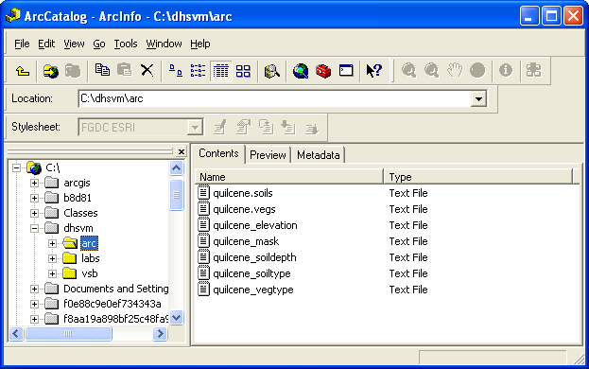

Next, activate ArcToolbox by clicking on the red toolbox icon on the tool bar:

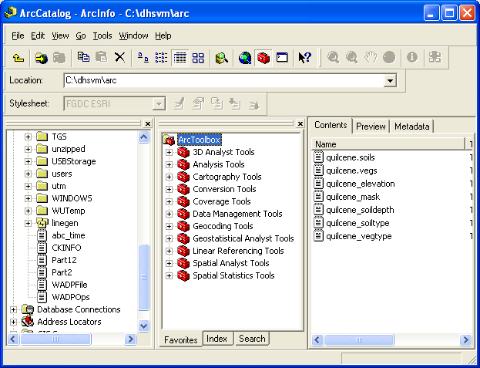
To import the raster data into ArcGIS format open the dialog for converting ASCII grids to raster
(ArcToolbox > Conversion Tools > To Raster > ASCII to Raster)

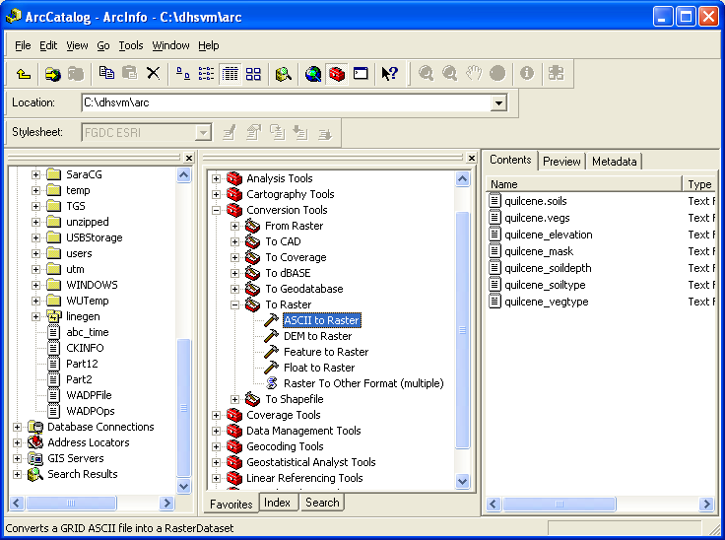
This will bring up the ASCII to Raster Dialog:

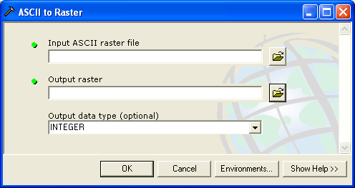

There are three items in the dialog:

- The full path to the original ASCII raster file
- The full path to where the tool will store the converted raster file
- The type of data that the raster holds.

Rasters can contain integer data or floating point data. Integers are whole numbers only (0, 1, 2, 3, …) . In GIS integers are used to identify classes of things. For example a Vegetation class of 1 might equal Coniferous Forest; a class of 2 might equal Deciduous Forest, etc. A floating point number is a Real number (i.e., a number with decimal points). Floating point numbers are used to represent measurements of a single variable such as elevation, precipitation, radiation, etc. It is OK to store an integer grid in a floating point format. You won’t lose any information. It is BAD to store a floating point grid in an integer format because all of the data after the decimal point will be truncated (NOT ROUNDED!).

By default, ArcGIS will assume that integer grids represent Categories of data and assume that floating point grids represent Fields of data. This affects how some tools work and how the data are displayed. It is a good idea to get the grid-type correct when importing data so these features work without problems.

In our example, we will convert quilcene_elevation.asc to ArcGIS format. Open up quilcene_elevation.asc in Notepad and scroll down a bit to see what type of numbers the elevations are stored as (integer or floating point). Notice that the elevations are recorded in floating point format so the type of data is Floating Point.

Fill in the dialog box of the ASCII to Raster Dialog so that it stores the new grid in the same directory as the original data.

Note that you can use the little folder icon to bring up a File Choose dialog. But, you will need to change the Files of type filter to *ASC to see the input grids as shown here.

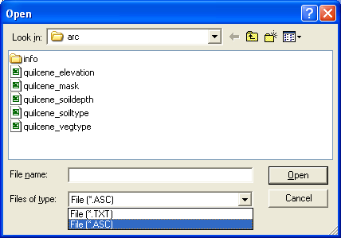

I called the new grid elevation. It should look something like this:

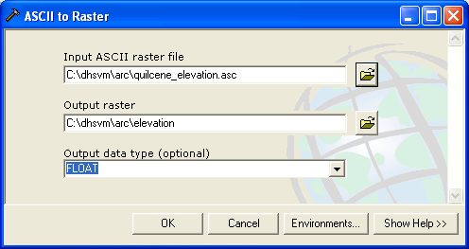
Click OK to start the wizard. When the wizard is finished it will say Completed. Click Cancel to exit the dialog.

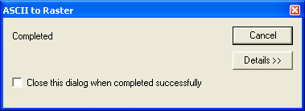
You should now be able to see the new raster in ArcCatelog.
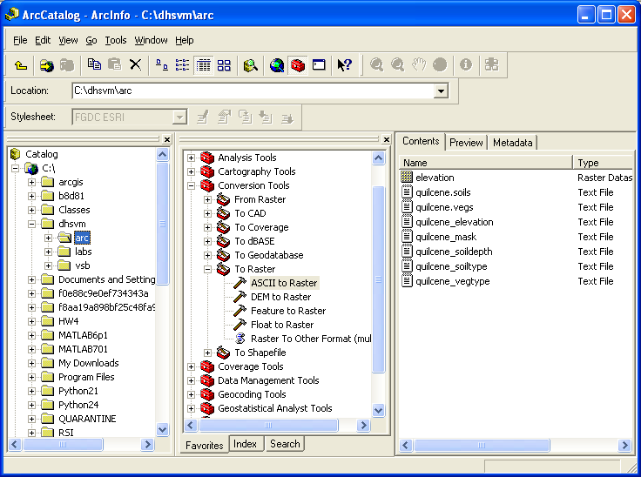

If you do not see elevation in the contents pane, try hitting the F5 key to refresh the directory. If it is still not there, you probably saved the file in another location.

Convert the remaining *asc files to ArcGIS format using the following names and types:

Original Name | New Name | Type
quilcene_elevation.asc | elevation | Float
quilcene_mask.asc | mask | Integer
quilcene_soildepth.asc | soildepth | Float
quilcene_soiltype | soiltype | Integer
quilcene_vegtype | vegtype | Integer

When you are done, your directory in ArcCatelog should look like this:
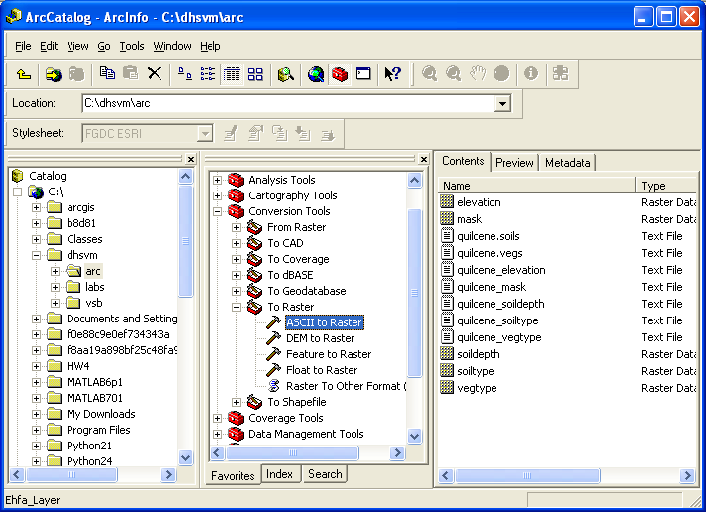

Georeferencing

The next step before we can use the data is to tell ArcGIS where in the world this data is located (coordinate system), what map projection will be used, what approximation to the shape of the Earth we are using (spheroid) and where the origin of our coordinate system is (datum). This process is known as Georeferencing. Obviously, it can be very complicated for some datasets.

In our case, our data already have all these things; we just need to tell ArcGIS what they are. Our data sets are in the Universal Transverse Mercator (UTM) coordinate system. UTM defines all of the above (coordinate system, spherioid, datum, etc.). All we need to do is assign the appropriate UTM zone to our data and all of the rest will be assigned per the standards.

To assign the UTM system to our data we use the Define Projection tool in ArcToolbox:

ArcToolbox > Data Management Tools > Projections and Transformations > Define Projection

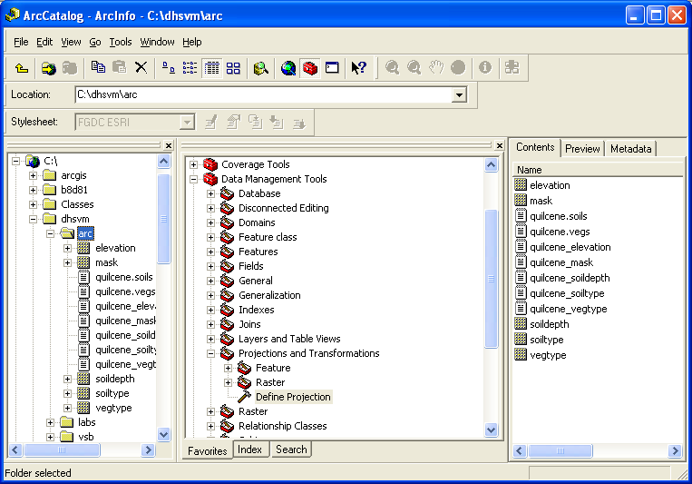

Open the Define Projection wizard. Fill in the path to the elevation raster we made in the last step:

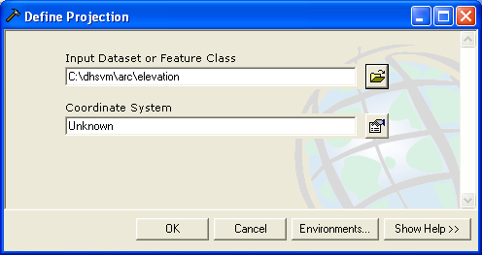
To fill in the coordinate system box, we click the little hand and paper icon. This brings up the Spatial Reference Properties:

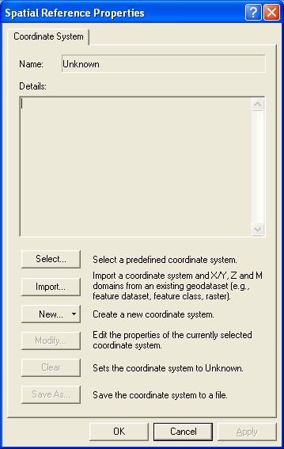
Click Select to bring up the Browse for Coordinate System Dialog:

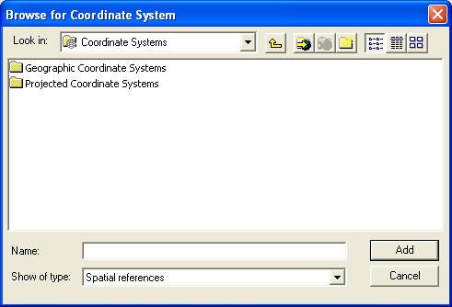

UTM is a Projected Coordinate System (as opposed to Geographic system like Latitude and Longitude you would get from a GPS unit).

Select Projected Coordinate Systems > UTM > Nad 1927 > NAD 1927 UTM Zone 10N.prj

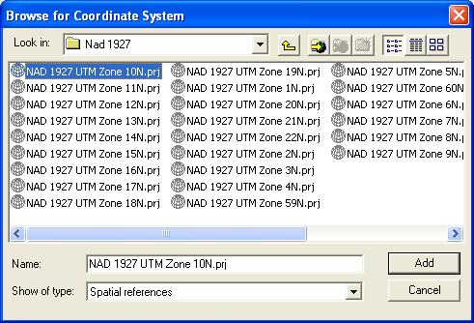
Click Add.

Your Spatial Reference Properties Dialog should now look like this:
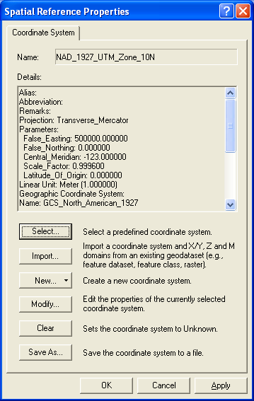
Click Apply.

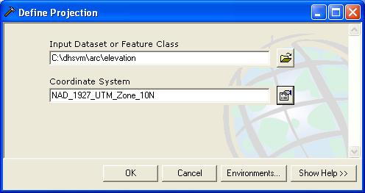
Notice that the Coordinate System name is now filled in. Click OK to assign NAD_1927_UTM_Zone_10N to elevation.

Now, assign the same projection to the remaining rasters in our directory. Hint: rather than going through the entire Coordinate System dialog again, just copy and paste the name NAD_1927_UTM_Zone_10N into the Coordinate System box and click OK.

When you are done assigning the projections to all of the rasters, can close ArcToolbox by clicking on the red toolbox icon again.

Checking Your Work

You can view information about your data in ArcCatelog. Make sure that you can see your datasets in the left pane as shown (you may need to expand the working folder):

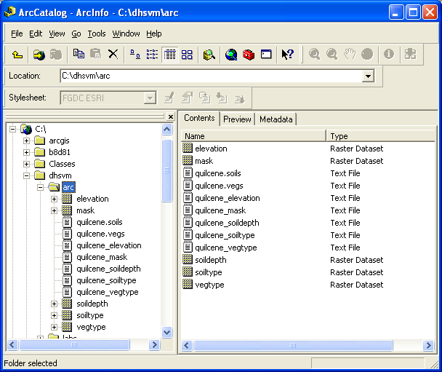
By clicking on your working folder (mine is called Arc), you should be able to see the contents in the Right Pane of ArcCatelog. Notice that ArcCatelog tells you what type of data you have and changes the icon to waffle-thing to indicate that this is a raster data set that ArcGIS recognizes.

Select one of the datasets, like elevation. Then click the Preview tab on the Right pane. You should see a preview of the raster data:

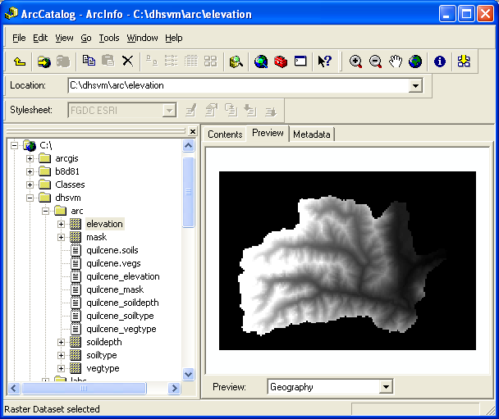
Notice the difference between the floating point rasters like elevation and soildepth and the Categorical rasters like soiltype and vegtype?
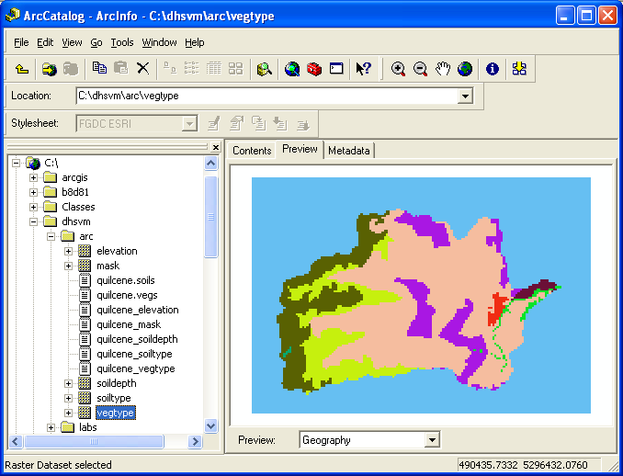

Saving your work
ArcMap saves all of your work in an Arcmap Document (mxd format). To save your project:

File > Save As

And save your project to the working directory

This is the end of Lab 1.

You should now be able to use ArcCatelog to import data into ArcGIS.
You should be able to use ArcToolbox dialogs for working with raster datasets.

